EFFICIENT ELECTRIFICATION OF ROUND STEEL BARS HEATING DURING ROLLING PROCESS

P. Jimbert (1), R. Fernandez (1), R. Vivanco (1), I. Crespo (2), I. Vicario (2)
(1) University of the Basque Country UPV/EHU, Spain.
(2) Metal Processing Platform, TECNALIA, Basque Research and Technology Alliance (BRTA), Spain.

KEYWORDS: INDUTION HEATING – DECARBONIZATION – MATHEMATICAL MODELLING – OPTIMIZATION

INTRODUCTION

The steel industry is one of the largest emitters of CO2, responsible for 7-9% of global anthropogenic CO2 emissions [1]. On the path towards achieving the EU's 2050 net-zero steel emissions target, one strategy related to the steel making industry involves transitioning from heating processes that emit greenhouse gases (such as natural gas furnaces) to electric heating processes (such as resistance furnaces or induction heating systems). This industrial transition from fossil fuel heating systems to electricity-based solutions is crucial to mitigating climate change [2].

METHODOLOGY

This study presents a methodology for this industrial transition using finite element simulations with ANSYS Multiphysics ® and adjusting the model with laboratory experiments applied to the induction heating process of round steel bars during the rolling process (but it can also be applied to heat treatments or preheating for hot forging).

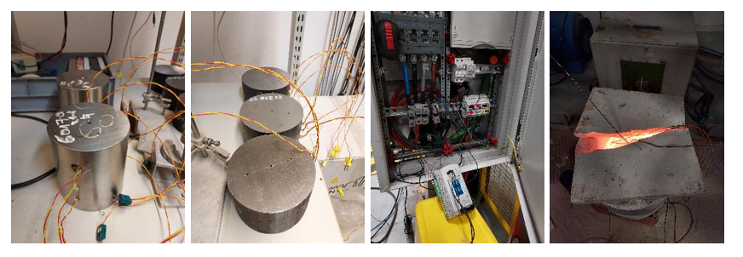
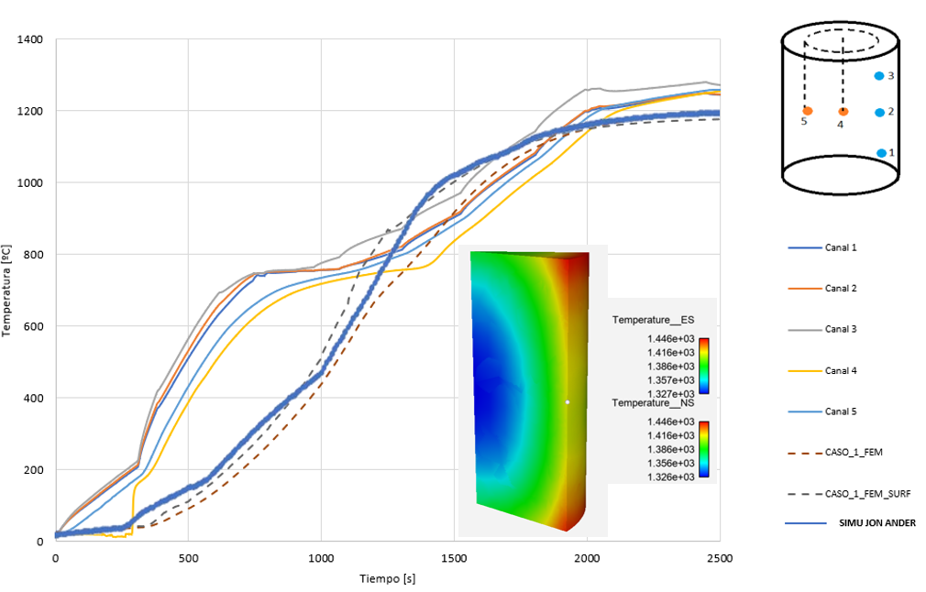
Fig.1 – Adjustment of experimental and simulation heating curves.
Finally, based on all the data obtained, a mathematical model capable of predicting temperature evolution based on the input parameters has been developed.

RESULTS

The results obtained demonstrate the usefulness of this methodology to help on the efficient optimization of this heating process.

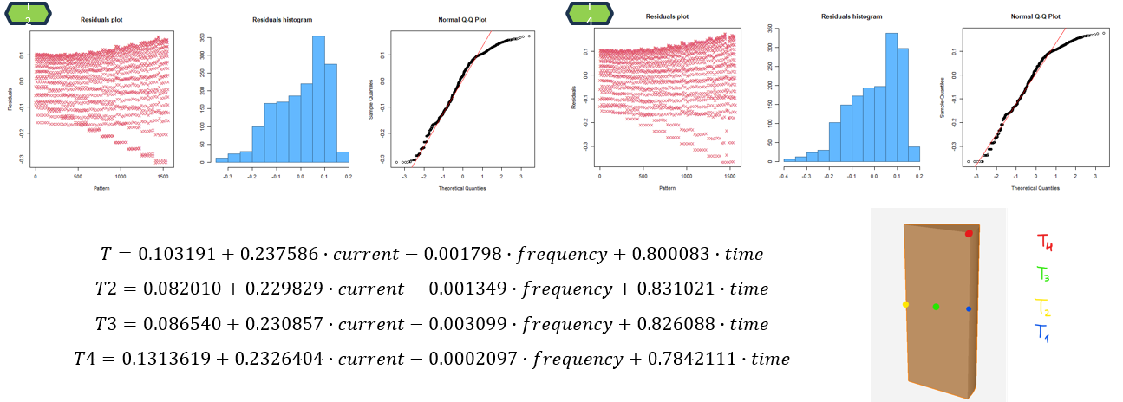

Fig.2 – Results of the different temperatures of the steel bar calculated with the developed mathematical model, after the followed simulation strategy.

This tool can be very useful for designing and optimizing the appropriate parameters (electric current and frequency) of this new electric heating process for round steel bar products, depending on the characteristics of the steel bar: such as its size, length or chemical composition or the process constraints: such as temperature gradients within the bar, energy consumption or process time.

FUNDING

This research was funded by KK-2025/00041 and KK-2023/00020 projects by the Basque Government under its ELKARTEK Research Program.

REFERENCES

- https://worldsteel.org/wp-content/uploads/Climate-change-production-of-iron-and-steel-2021.pdf
- Arman Ashabi, Mohamed Mostafa, Andriy Hryshchenko, Ken Bruton, Dominic T.J. O’sullivan, Assessing power-to-heat technologies for industrial electrification: A multi-criteria decision analysis approach, Energy Conversion and Management: X, Volume 25, 100882, 2025. https://doi.org/10.1016/j.ecmx.2025.100882.

