OPTIMIZING INDUCTION HEATING FOR STEEL BILLETS: A MULTIPHYSICS APPROACH TO ELECTRIFICATION AND DECARBONIZATION
Maria Freda, Franco Macci, Edoardo D'Amanzo, Ilaria Salvatori, Matilde Breda
RINA Consulting – Centro Sviluppo Materiali (CSM), Rome, Italy
The thermal condition of steel billets prior to hot rolling plays a key role in ensuring process stability and suitable hot-working conditions. In microalloyed steels, excessive cooling may cause portions of the billet to enter temperature ranges associated with reduced ductility, increasing the likelihood of defect formation during deformation. Within the Horizon Europe ModHEATech project, a coupled electromagnetic-thermal finite element model was applied to investigate the thermal evolution of steel billets during transfer from reheating furnace to rolling mill. The multiphysics model enables the evaluation and optimization of key process variables, including billet geometry, inductor positioning, operating frequency, power-supply conditions, and productivity requirements, and their influence on billet thermal behavior. Three billet geometries having the same cross-sectional area were considered: two round-cornered square (RCS) billets with different corner radii and one round billet. The study evaluates the effectiveness of compensative induction reheating in reducing thermal gradients and maintaining temperatures above critical hot-working thresholds. The results indicate that billet shape strongly influences heat-loss distribution, while induction reheating effectively restores thermal homogeneity. The proposed simulation-based approach provides useful guidelines for the design of robust and efficient reheating strategies in industrial rolling operations, supporting process electrification, improving production efficiency and product quality, and contributing to more sustainable and competitive steel manufacturing.
KEYWORDS: Induction Heating – Steel Billets – Decarbonization – Electrification – Hot Rolling – Multiphysics Simulation

INTRODUCTION

Hot rolling operations require accurate thermal control to ensure proper material workability and product quality. During transport from the reheating furnace to the rolling mill, steel billets experience progressive heat losses that may generate significant temperature non-uniformities. These effects are particularly critical in microalloyed steels, whose ductility decreases within specific temperature intervals. Compensative induction reheating represents an effective solution for restoring billet temperature before deformation. By generating heat directly within the material, induction systems can compensate for thermal losses while maintaining productivity and process flexibility. Moreover, the reduced residence time at elevated temperatures achievable through induction heating can limit scale formation and surface decarburization, thereby improving product quality and reducing material losses. In addition to process operating parameters, billet geometry significantly affects thermal behaviour because it governs the distribution of heat losses across the cross-section. To investigate these effects, a coupled electromagnetic-thermal simulation approach was employed to compare different billet geometries under identical transfer and reheating conditions. Beyond its metallurgical and process-related benefits, induction heating is increasingly recognized as a key enabling technology for the electrification and decarbonization of steelmaking processes. Owing to its high Technology Readiness Level (TRL), electromagnetic induction is particularly suitable for industrial implementation in existing rolling plants.

RESULTS AND DISCUSSION

A three-dimensional coupled electromagnetic-thermal finite element model was used to analyse three billet geometries with identical cross-sectional area: RCS billets with 5 mm and 40 mm corner radii, and a round billet. The simulations revealed a marked influence of geometry on temperature evolution during transfer. Without induction heating, the RCS configurations developed significant corner cooling and higher thermal gradients, particularly for the billet with the smaller corner radius. Conversely, the round billet exhibited a more uniform temperature field due to the absence of geometrical discontinuities. The introduction of compensative induction reheating substantially modified the thermal field by compensating transfer-line heat losses and reducing temperature differences throughout the section. Under the investigated operating conditions, billet temperatures remained above the critical range associated with reduced ductility, with the most significant improvements observed in the RCS geometries. The simulations were performed under representative industrial operating conditions, considering electromagnetic parameters such as frequency and power supply settings, whose influence on thermal homogeneity was assessed through the coupled multiphysics approach. In addition, the numerical model enabled the evaluation of induced current-density distributions within the billet cross-section, providing further insight into the relationship between billet geometry, electromagnetic field penetration, and thermal uniformity.
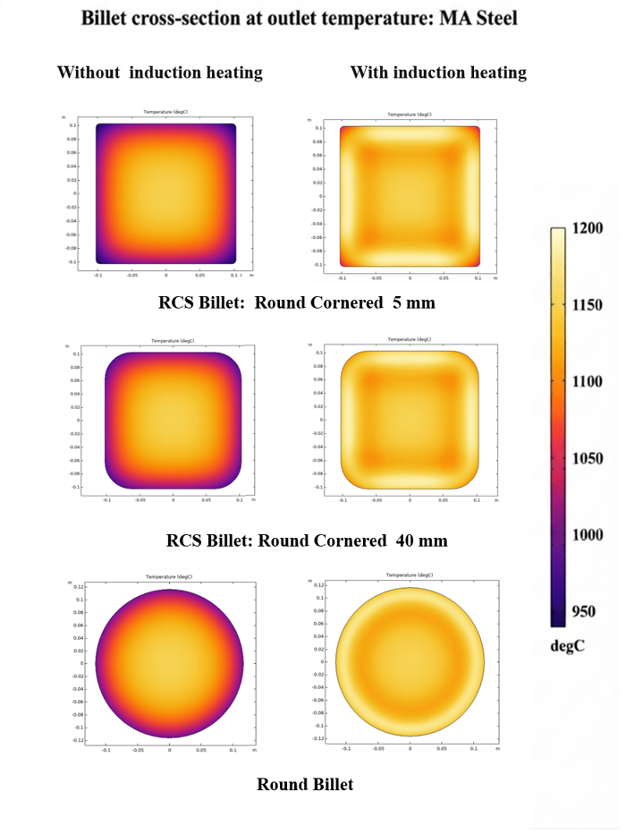
Fig. 1 – Cross-sectional temperature maps at rolling mill entry for the investigated billet geometries with and without induction heating.

CONCLUSIONS
The numerical analysis demonstrated that both billet geometry and reheating strategy contribute to the thermal conditions achieved before rolling. Simulation results showed that compensative induction heating effectively limits thermal non-uniformities and maintains billet temperatures within the optimal range for hot deformation. The predictive capability of the numerical model was supported by laboratory testing activities performed on billet specimens, which were used for calibration and validation purposes. These results highlight the value of simulation-based design as a support tool for optimizing induction-assisted reheating systems, improving process robustness, and facilitating the implementation of more efficient and electrified steel-production routes.

REFERENCES
[1] Rudnev, V., Loveless, D., Cook, R., & Black, M. (2017). Handbook of Induction Heating (2nd ed.). CRC Press.
[2] Li, Y., & Tsukamoto, T. (2013). Numerical simulation of induction heating process considering temperature-dependent properties. Applied Thermal Engineering, 50(1), 178–185.
[3] Mintz, B., & Qaban, A. (2021). Understanding the high temperature side of the hot ductility curve for steels. Materials Science and Technology, 37(3), 237–249.
[4] International Energy Agency (IEA) (2020). Iron and Steel Technology Roadmap.
[5] Freda, M., Macci, F., D’Amanzo, E., Colaneri, A., Santisteban, V. M. (2024). Induction Heating Optimizing for Steel Billets. COMSOL Conference.

