A CAD/CAE Integrated Simulation Method for Forging Press Hydraulic Systems Based on Model Parameter Mapping

ZHAI Fugang¹, YANG Zhuofan¹, HE Zhiqiang^{1,2}, LIU Caiyi^{1,2}, KARIMI Hamid Reza²
¹ School of Mechanical Engineering, Yanshan University, Qinhuangdao 066000, China
² Department of Mechanical Engineering, Politecnico di Milano, Milan 20156, Italy

This study proposes a CAD/CAE integrated simulation method for forging press hydraulic systems. Through parameter mapping, CAD structural parameters are automatically transferred to AMESim models, while Python scripts enable automated simulation and result processing. An integrated platform combining parametric modeling, dynamic simulation, data analysis, and visualization is developed, improving modeling consistency, simulation efficiency, and design iteration capability.

KEYWORDS: Design–Simulation Convergence – Parameter-Driven Modeling – Automated Simulation Workflow – Visual Decision Support

PARAMETRIC MODELING OF THE HYDRAULIC SYSTEM
Forging presses are key equipment for the high-precision forming of large forgings, and their hydraulic systems directly affect loading capacity, motion accuracy, and forming stability (1). To meet increasing requirements for forming quality and production efficiency, hydraulic-system design should support quantitative analysis of dynamic response, parameter influence, and scheme performance at the design stage. However, conventional design methods still rely heavily on engineering experience, while CAD models, CAE simulation models, and visualization models are often separated (2). Therefore, this study proposes a CAD/CAE integrated simulation method based on model parameter mapping to connect design modeling, dynamic simulation, result analysis, and model verification within a unified workflow, as shown in Fig. 1.

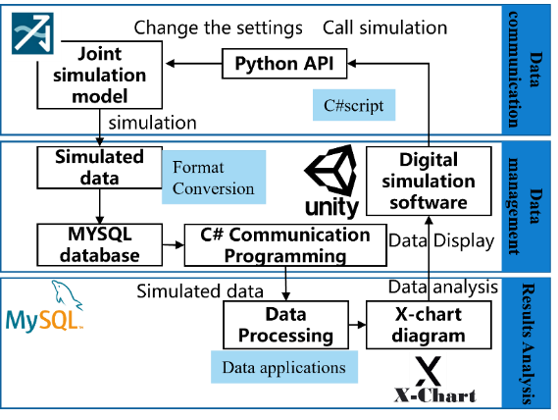

Fig.1 - CAD/CAE integrated simulation technology route

The proposed method first analyzes the structure and working mechanism of the forging press hydraulic system, including hydraulic cylinders, pumps, control valves, accumulators, and pipelines (3). Based on these components, a parametric model for system-level simulation is established. Key parameters such as geometric dimensions, flow characteristics, pressure response variables, and motion-output parameters are extracted to form a unified parameter system. Since the structural dimensions in CAD models cannot be directly used as CAE simulation variables, parameter conversion is carried out according to the physical meaning and modeling requirements of the hydraulic system.
CAD/CAE PARAMETER MAPPING MECHANISM

A cross-platform parameter mapping mechanism is constructed between the CAD design model and the CAE simulation model. By calling the CAD software API, the external program can automatically access the feature tree, dimension objects, and custom attributes of the three-dimensional model, extract key structural parameters, and complete unit unification, format conversion, and validity verification (4). The processed parameters are then written into an intermediate file or database and read by the CAE model to update component parameters, system parameters, and simulation settings, thereby reducing repeated manual modeling and improving consistency between design and simulation.

AUTOMATED SIMULATION EXECUTION FRAMEWORK

To improve simulation efficiency, an automated simulation execution framework based on AMESim and Python scripts is developed. The Python program acts as the upper-level control module, responsible for parameter reading, model calling, variable assignment, simulation solving, result extraction, and data storage. Before simulation, the mapped parameters are automatically written into the AMESim model to modify global parameters and submodel variables. After simulation, key variables such as moving-beam displacement, hydraulic-cylinder pressure, valve opening, and flow rate are automatically extracted and stored for curve analysis, multi-condition comparison, and experimental validation.

PLATFORM IMPLEMENTATION AND RESULT ANALYSIS

Based on the proposed method, a CAD/CAE integrated simulation platform for forging press hydraulic systems is developed, as shown in Fig. 2. The platform integrates parametric modeling, simulation parameter setting, automated dynamic simulation, multi-source data import, result-curve analysis, data export, and three-dimensional motion visualization (5). Designers can import hydraulic component models, extract key parameters, complete the mapping between structural and simulation parameters, and evaluate system performance through simulation curves and visualization results. The results show that the proposed method improves multi-condition simulation efficiency, parameter iteration capability, and the consistency, traceability, and interpretability of simulation results.

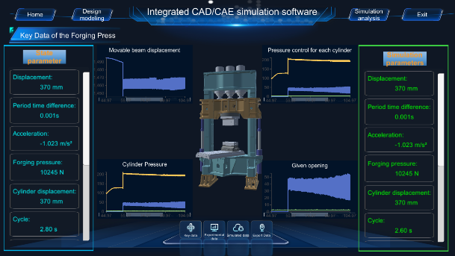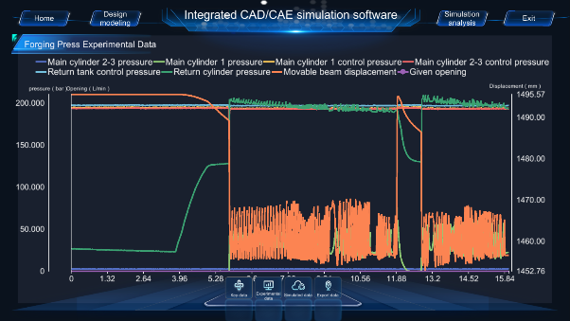

Fig.2 - Effect of the CAD/CAE integrated modeling and simulation platform
REFERENCES

- Tao F, Liu WR, Zhang M, et al. Digital twin five-dimension model and its ten applications. Computer Integrated Manufacturing Systems. 2019;25(01):1-18.
- Song XG, Lai XN, He XW, et al. Key technologies of digital twin for integrated shape-performance design of major equipment. Journal of Mechanical Engineering. 2022;58(10):298-325.
- H A, J LH, K S, et al. Simulation of wear in hydraulic percussion units using a co-simulation approach. International Journal of Modelling and Simulation. 2023;43(3):265-281.
- Zhang KG, Liu YJ, Xue G, et al. Research on compliant control of iron roughneck based on electromechanical-hydraulic co-simulation. Machine Tool & Hydraulics. 2024;52(19):124-129.
- Zhang H, Ma LQ. Research on three-dimensional model lightweight technology architecture and quality evaluation method of digital twin system. China Standardization. 2024;(21):99-103.

