WELDABILITY INVESTIGATION OF INDUSTRIAL HEAVY PLATE STEELS FOR PRESSURE VESSELS DESIGNED FOR MOBILE CO₂ STORAGE APPLICATIONS

Andrei Filatov, Eugene Goli-Oglu
NLMK DanSteel, Havnevej 33, 3300 Frederiksvaerk, Denmark

This work presents an investigation of pressure vessel steels P355NL2 and P460NL1 according to EN 10028-3. Heavy plates 16–50 mm thick were produced at NLMK DanSteel for CCS projects using controlled rolling and heat treatment. P355NL2 was supplied in normalized condition (+N) and showed a homogeneous ferrite-pearlite microstructure with a stable combination of strength and low-temperature toughness. P460NL1 was produced in normalized rolled condition (+NR) and provided higher yield strength with sufficient toughness. These steels represent two engineering approaches for pressure vessel construction: normalized plates with stable weldability and higher-strength plates allowing lower structural weight. For P355NL2, testing included plate-by-plate tensile tests, impact toughness at −50 °C and −45 °C, hardness measurements, and samples after simulated post-weld heat treatment (sPWHT). For P460NL1, testing included tensile tests, impact toughness at −40 °C and −50 °C, and hardness measurements. The results confirm that both steels meet EN 10028-3:2017 requirements and demonstrate stable mechanical properties and weldability for mobile CO₂ pressure vessels.

KEYWORDS: CO2 STORAGE – PRESSURE VESSEL – MARITIME TRANSPORTATION – STEEL – HEAVY PLATE – MECHANICAL PROPERTIES – WELDABILITY

INTRODUCTION

The reduction of carbon emissions is regarded as both an environmental challenge and a factor driving technological development. In this context, carbon capture, transportation and storage (CCS) are increasingly important elements of low-carbon infrastructure [1,2].
Steel tanks for liquefied CO₂ are critical and metal-intensive elements of CCS systems. Depending on the selected concept, ship transport may be carried out at 6-7 bar and about -45 °C or at pressures up to 15 bar and temperatures of about -28 °C [3,4]. Mobile pressure vessels (MPVs) must therefore maintain reliable performance at subzero temperatures under cyclic loading. Their wall thickness commonly ranges from 30 to 50 mm, and they are generally designed as cylindrical shells with elliptical or torispherical heads connected by circumferential and longitudinal welds [5,6].
Low-carbon fine-grain steels supplied in normalized (+N) or normalized-rolled (+NR) condition according to EN 10028-3 are widely used for such applications. The P355NL2-P460NL1 family provides specified yield strengths from 355 to 460 MPa and is used in pressure-vessel structures subject to applicable pressure-vessel and maritime classification requirements [7].
A representative project for marine transportation and temporary storage of CO₂ generated from Danish biogas plants used MPVs fabricated from P355NL2 heavy plate supplied in normalized condition. The cylindrical shell was approximately 37 mm thick and the elliptical heads approximately 43 mm thick [8,9]. After submerged arc welding, the complete vessel was stress-relief heat treated at 560-580 °C. The tanks were installed in the cargo hold of a specialized vessel for offshore injection of CO₂ into depleted gas reservoirs in the North Sea (Fig. 1).

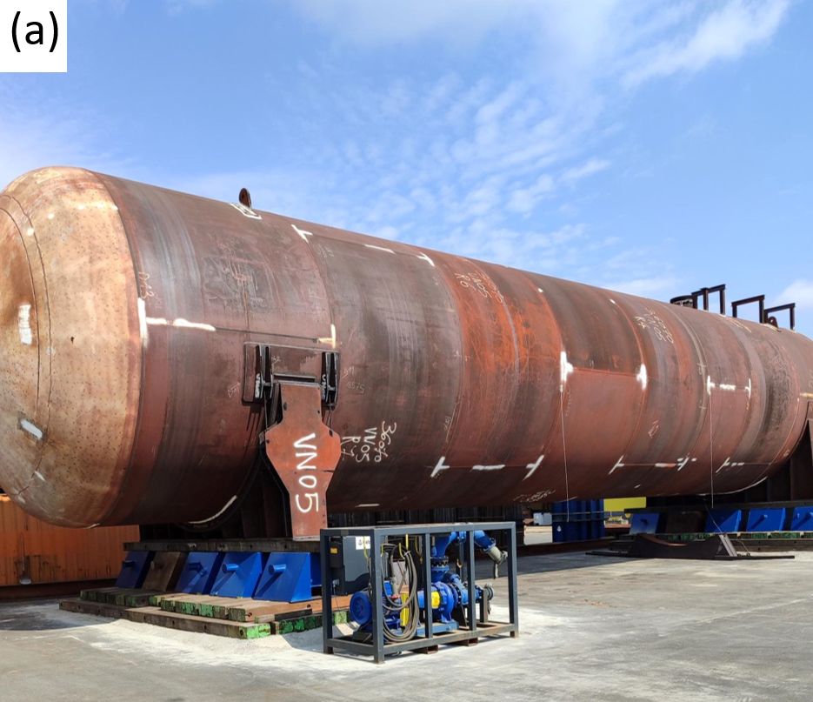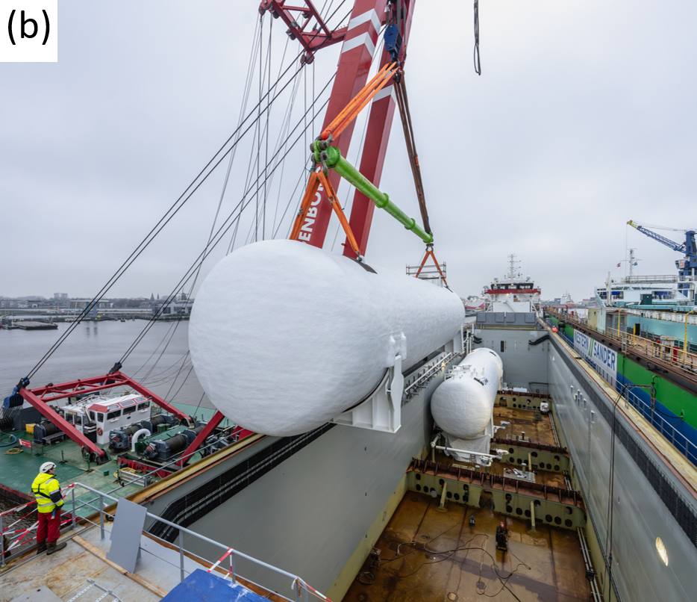

Fig.1 - Pressure vessel for liquefied CO₂ storage manufactured from P355NL2 heavy plate (a) and loading of MPVs for subsequent injection into depleted natural gas reservoirs (b).

Another CCS industrial project used 34 mm P460NL1 heavy plate in normalized-rolled condition for large mobile CO₂ storage tanks. The tanks had a diameter of 7.2 m, a length of 56 m and a mass of approximately 380 t. About 4000 t of steel had been supplied by the end of 2024. The higher-strength P460 concept allows a reduction in vessel wall thickness and structural weight compared with P355-grade steel; design calculations according to EN 13445-3 indicate a potential weight reduction of about 25-30%.
These projects were realized in cooperation between NLMK DanSteel as heavy plate producer and Geldof (Engicon Group) as designer and manufacturer of pressure vessels and storage tanks.
The aim of the present work is to compare industrial-scale quality, microstructure, mechanical properties and weldability of P355NL2 and P460NL1 heavy plate steels intended for mobile pressure vessels for marine transportation and temporary storage of liquefied CO₂.

MATERIALS AND METHODS

The investigated steels were produced in a basic oxygen furnace and cast into continuously cast slabs 330-360 mm thick, followed by rolling at the 4200 heavy plate mill of NLMK DanSteel, Denmark [10]. P355NL2 was produced in normalized condition, while P460NL1 was produced in normalized-rolled condition using a low-carbon C-Mn-Si-Al-Ni-Nb-V alloying concept. The chemical composition, carbon equivalent (CEQ) and crack resistance coefficient (PCM) of the investigated steels are presented in Tab. 1.

Tab. 1 - Chemical composition of the investigated steel (wt.%)

CHEMICAL COMPOSITION
Steel | C [%] | Mn [%] | Si [%] | S [%] | P [%] | N [%] | Nb [%] | CEQ [%] | PCM [%]
P355NL2 | ≤0.18 | ≤1.52 | ≤0.46 | ≤0.004 | ≤0.016 | ≤0.004 | + | ≤0.43 | ≤0.27
P460NL1 | ≤0.20 | ≤1.60 | ≤0.50 | ≤0.004 | ≤0.012 | ≤0.007 | + ^{a)} | ≤0.47 | ≤0.30
^{a)}Nb+V in a total amount not exceeding 0.10%

P460NL1 plates were rolled to a final thickness of 34 mm using a two-stage rolling scheme, with the second stage ending between Ac₃ and Ar₃, followed by air cooling. P355NL2 plates were rolled in a single stage with individual pass reductions of 10-21% to a final thickness of 30-50 mm, then reheated in a normalizing furnace at 900-905 °C and cooled in still air. The normalizing cycle for 37 mm plates consisted of intensive heating and soaking; the normalizing temperature was reached within 48-50 min, soaking lasted 14-16 min, and the total heating time was 62-68 min (x̄ = 64.9 min; σst = 1.9 min). The temperature at the end of intensive heating was 901-904 °C (x̄ = 902.3 °C; σst = 1.4 °C), confirming stable heat-treatment conditions (Fig. 2). This route ensured a homogeneous ferrite-pearlite microstructure.
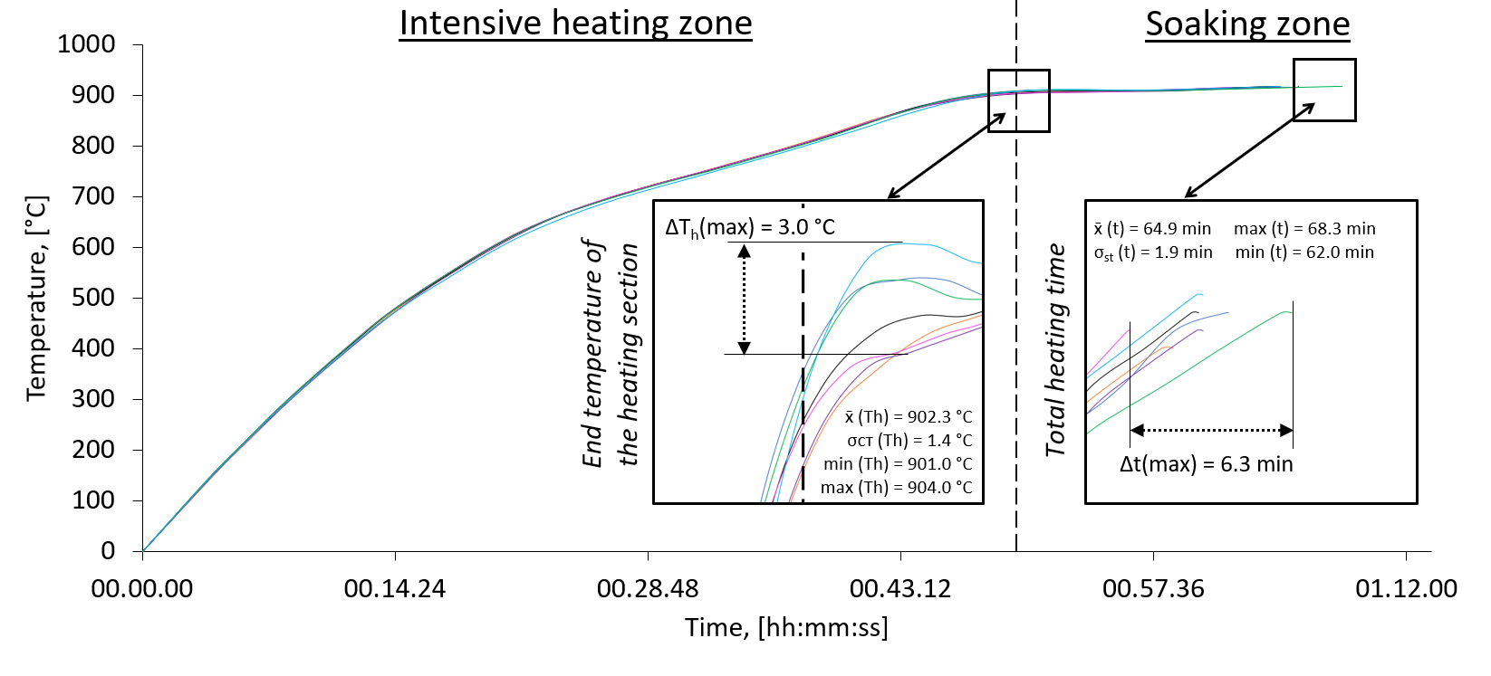

Fig.2 - Normalizing furnace heating curves for 37 mm plates of the investigated steel.

Plate-by-plate acceptance testing of P355NL2 was performed at head and tail ends. Part of the P355NL2 samples underwent simulated post-weld heat treatment (sPWHT): heating at 55 °C/h to 580 ± 3 °C, holding for 60 min and cooling to 300 °C at the same rate. Tensile testing was performed according to EN ISO 6892-1, Charpy impact testing according to EN ISO 148-1 and Vickers hardness measurements according to EN ISO 6507-1. Ultrasonic testing of P460NL1 was performed according to ASTM 578. Macroanalysis was carried out according to ISO 17639 after 5% nital etching; microstructural investigations used optical and scanning electron microscopy. Material directions were defined as rolling direction (RD), normal direction (ND) and transverse direction (TD).
Weldability was assessed on 37 mm P355NL2 and 34 mm P460NL1 joints produced by automatic submerged arc welding (SAW) with a heat input of 1.5 ± 0.1 kJ/mm. P355NL2 was welded using symmetric X-groove preparation with OP 121TT flux, OE SD3 wire and copper-coated BÖHLER 2.5Ni-IG wire. P460NL1 was welded with a symmetric 20° V-groove on a PEMA welding station using OP 128TT flux and OE14MO-4-25VCI wire. For P460NL1, controlled thermal severity (CTS) and bead-on-plate (BoP) tests were additionally performed to evaluate crack susceptibility and local HAZ hardening.

RESULTS AND DISCUSSION

PRESSURE VESSEL STEEL P355NL2 IN NORMALIZED CONDITION

P355NL2 Base Metal Properties
Microscopic examination in the RD-ND section showed a homogeneous ferrite-pearlite through the plate thickness (Fig. 3). The structure consisted predominantly of polygonal ferrite (approximately 87-92%) with finely dispersed pearlite (8-13%). The average equivalent ferrite grain diameter was about 10-11 μm and increased to 11-12 μm toward mid-thickness After simulated stress-relief heat treatment (sPWHT), no changes in phase composition were observed and the structure remained uniform.

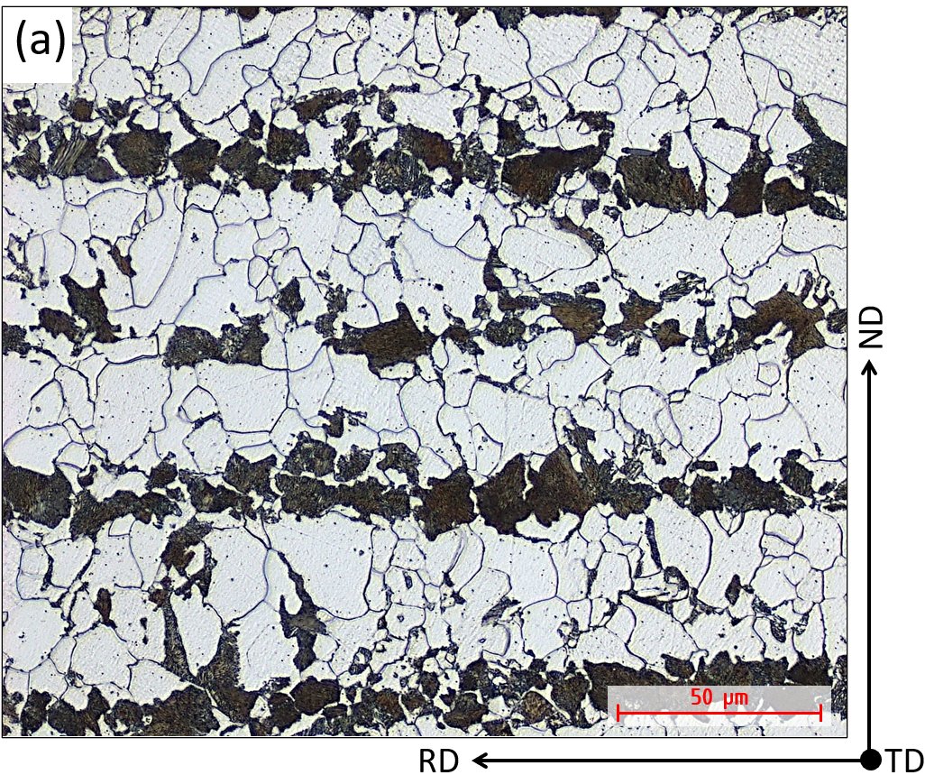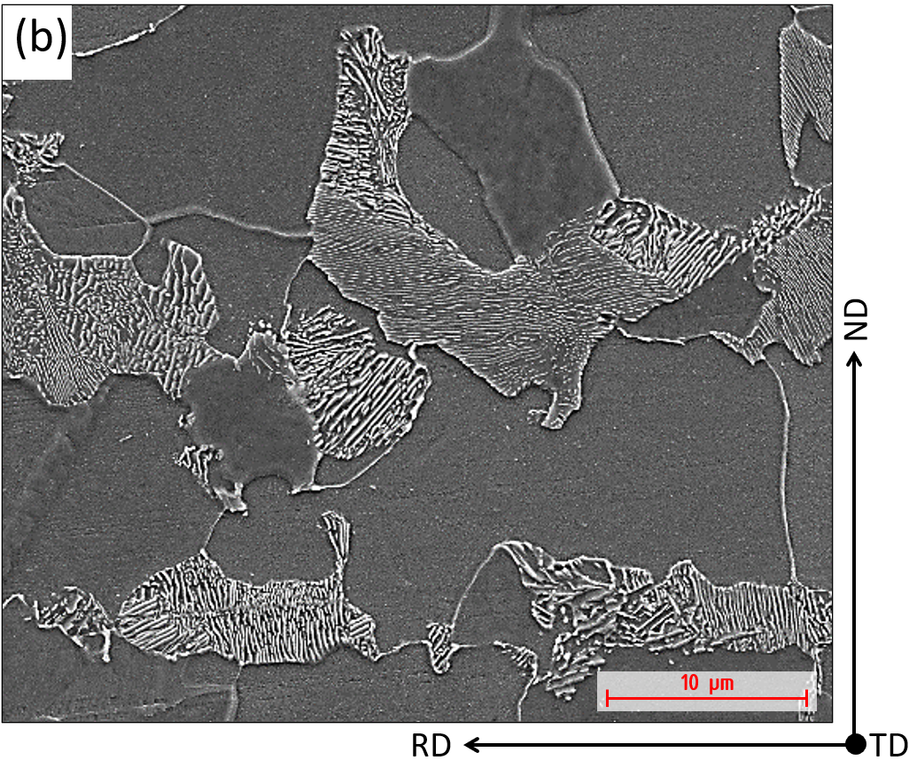

Fig.3 - Microstructure of 37 mm P355NL2 plate after normalized: optical (a) and scanning electron microscopy (b).
Hardness measurements on 120 plates gave a mean value of 159 HV10 after normalization (151-171 HV10; σst = 2.5 HV10) and 156 HV10 after sPWHT (145-166 HV10; σst = 1.4 HV10), indicating structural stability without noticeable softening.
The main mechanical properties are summarized in Tab. 2. In all conditions, the impact energy values exceeded the EN 10028-3 requirements and demonstrated a stable reserve of low-temperature toughness.

Tab. 2 - Summary of P355NL2 base-metal mechanical properties.

MAIN MECHANICAL PROPERTIES OF P355NL2 (MIN–MAX/MEAN)
Condition | Yield strength,  R_{eH}, [MPa] |  | Ultimate tensile strength,  R_{m}, [MPa] |  | Elongation A₂₀₀, [%] | Impact energy  KVT-45, [J] |  |  | Impact energy KVT-50, [J]
 |  |  |  |  |  | surface | 1/4 | 1/2 | surface | 1/4
Condition | 16<t ≤40 | 40<t ≤60 | 16<t ≤40 | 40<t ≤60 | Elongation A₂₀₀, [%] | 16<t ≤40 | 40<t ≤60 |  | 16<t ≤40 | 40<t ≤60
Requirements of EN10028-3:2017 | ≥ 345 | ≥ 335 | 490–630 |  | ≥ 22 | - | - | - | ≥ 27 | ≥ 27
Investigated steel | $$\frac{\text{34}\text{8–}\text{44}\text{8}}{\text{372}}$$ | $$\frac{\text{345}\text{–389}}{\text{370}}$$ | $$\frac{\text{509–591}}{\text{531}}$$ | $$\frac{\text{515–530}}{\text{5}\text{23}}$$ | $$\frac{\text{28}\text{–3}\text{8}}{\text{33}}$$ | - | - | - | $$\frac{\text{56}\text{–}\text{173}}{\text{118}}$$ | $$\frac{\text{71–204}}{\text{146}}$$
Investigated steel + sPWHT | $$\frac{\text{345}\text{–}\text{4}\text{36}}{\text{367}}$$ | $$\frac{\text{34}\text{7–389}}{\text{37}\text{1}}$$ | $$\frac{\text{502–582}}{\text{52}\text{6}}$$ | $$\frac{\text{504–537}}{\text{5}\text{22}}$$ | $$\frac{\text{29–35}}{\text{33}}$$ | $$\frac{\text{6}\text{0–}\text{17}\text{7}}{\text{1}\text{22}}$$ | $$\frac{\text{76–196}}{\text{142}}$$ | $$\frac{\text{43–127}}{\text{95}}$$ | - | $$\frac{\text{70–180}}{\text{136}}$$

P355NL2 Welded Joint Properties
A high-quality X-shaped welded joint was obtained from 37 mm P355NL2 plates. Macroanalysis showed no pores, lack of fusion or cracks. The weld metal exhibited columnar dendrites and the HAZ was symmetric relative to the weld axis, with a width of approximately 6-8 mm on each side (Fig. 4). In the base metal, hardness ranged from 147 to 159 HV10. The maximum values of 209-227 HV10 were observed in the coarse-grained HAZ, while the weld metal showed stable values of 195-214 HV10; no soft zones were detected.

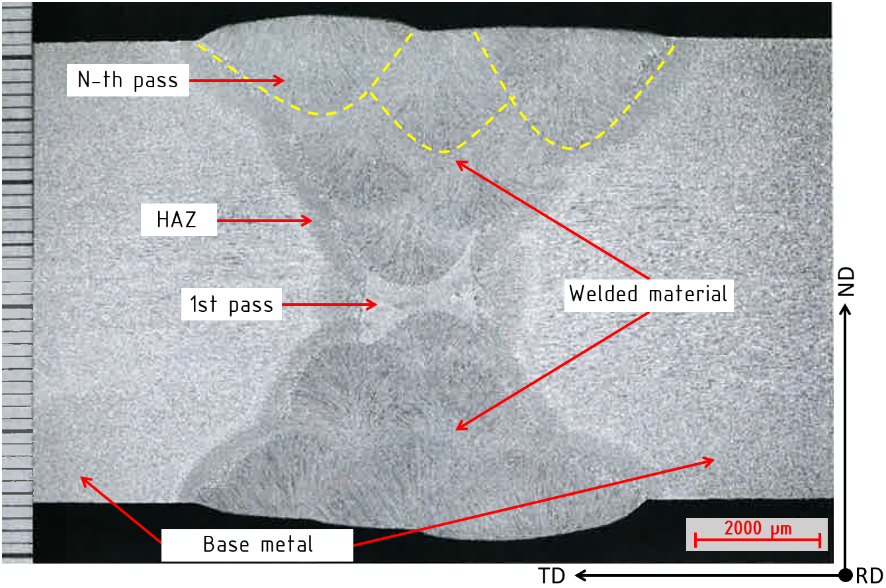

Fig.4 - Macrostructure of the X-shaped welded joint of P355NL2 steel after automatic submerged arc welding.

The strength characteristics of the welded joint are evaluated based on tensile tests of samples selected from the transverse cross-section of the weld and also from the weld metal. During testing of the transverse welded joint samples, the ultimate tensile strength is 532 MPa, and fracture occurs in the base metal, indicating a sufficient strength margin of the welded joint. Segmented impact testing at -45 °C gave the lowest toughness at the fusion line, where the impact energy was 34-106 J (x̄ = 71 J). At 1 and 3 mm from the fusion line, the average impact energy increased to 117 J, and at 5 mm it reached 150-160 J (x̄ = 156 J), corresponding to the level of the base metal (Fig. 5).
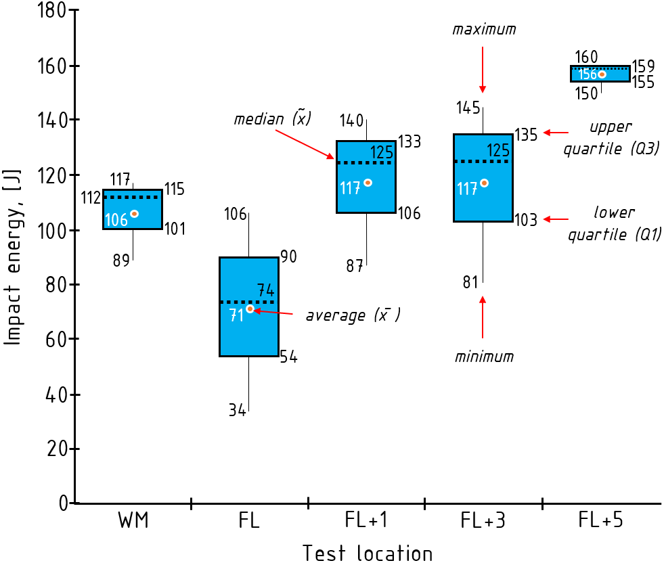

Fig.5 - Segmented impact energy of the P355NL2 welded joint at -45 °C.

PRESSURE VESSEL STEEL P460NL1 IN NORMALIZED ROLLED CONDITION

P460NL1 Base Metal Properties
The base metal microstructure consists of a ferrite-bainite mixture with a uniform distribution of phases and a high degree of homogeneity through the plate thickness (Fig. 6).

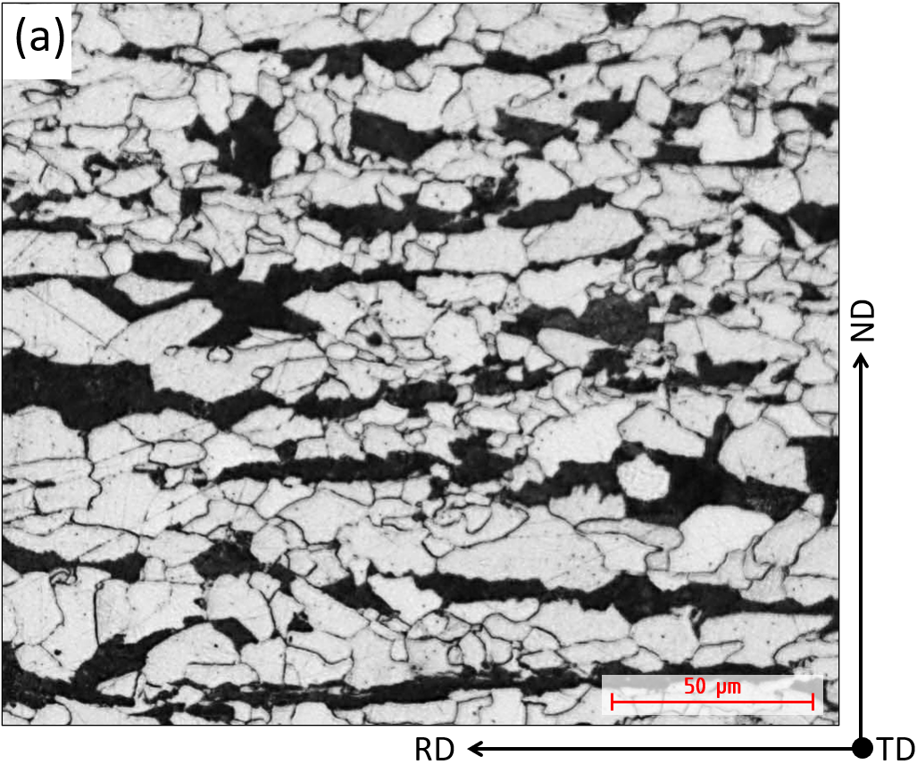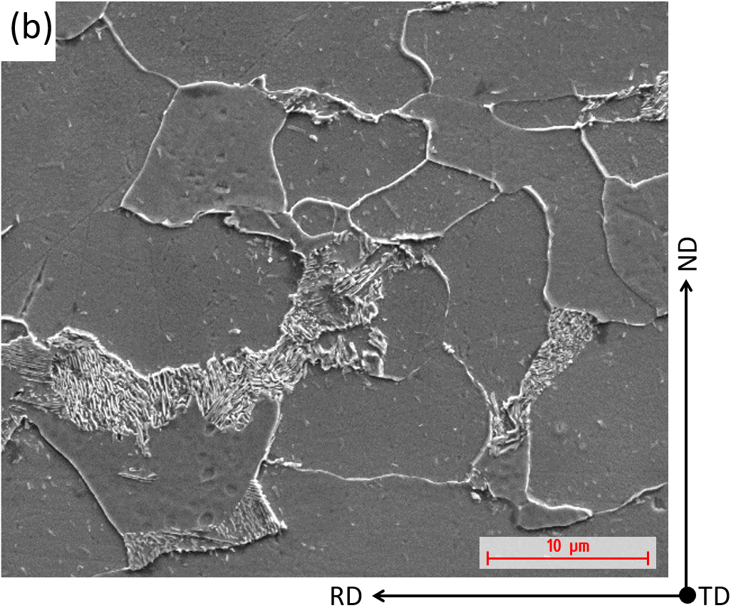

Fig.6 - Microstructure of 34 mm P460NL1 plate after normalized rolling: optical (a) and scanning electron microscopy (b).

Mechanical properties of the produced 34 mm plates in the as-delivered condition confirmed stable plate quality within the investigated batch (2000 t). The summarized results are presented in Tab. 2.

Tab. 3 - Summary of P460NL1 base-metal mechanical properties.

MAIN MECHANICAL PROPERTIES OF P460NL1 (MIN–MAX/MEAN)
Steel Grade | Yield strength for 16 < t ^{a)} [mm] ≤ 25, R_{eH}, [MPa] | Tensile strength, Rm [MPa] | Elongation, A₂₀₀  [%] | Impact energy (T/L) ^{b)}  KV at −20, [J] | Impact energy (T/L) ^{b)}  KV at −40, [J] | Ultrasonic  testing ^{c)}
Requirements of EN 10028-3:2019 for: P460NH,  P460NL1,  P460NL2 | ≥ 445  ≥ 445  ≥ 445 | 570–720  570–720  570–720 | ≥ 16  ≥ 16  ≥ 16 | ≥30/45  ≥35/50  ≥40/55 | -/-  27/40  30/45 | -  -  -
Investigated steel | $$\frac{\text{458}\text{–}\text{50}\text{6}}{\text{482}}$$ | $$\frac{\text{602}\text{–}\text{654}}{\text{632}}$$ | $$\frac{\text{23}\text{–}\text{29}}{\text{25}}$$ | 136/- | 105/- | ≥ class B
^{a)} t - rolled thickness, ^{b)} T – transverse direction, L – longitudinal direction, ^{c)} in accordance with ASTM 578
The investigated steel demonstrates a stable level of strength and impact toughness. The mechanical properties of the produced plates meet the requirements of EN 10028-3:2017 and provide a substantial margin at subzero temperatures, including average impact energy values of 136 J at −40 °C and 105 J at −50 °C.

P460NL1 Welded Joint Properties
Automatic SAW produced a sound V-shaped welded joint without visible defects (Figs. 7). The total width of the weld metal and HAZ was approximately 12-13 mm. The weld metal had a cast dendritic structure with pronounced columnar morphology.

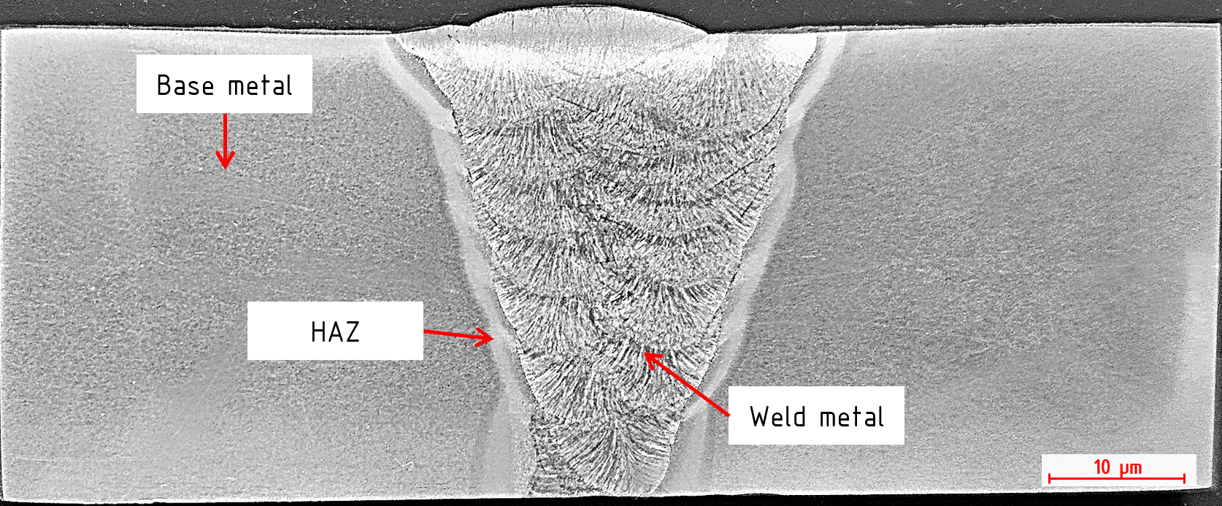

Fig.7 - Macrostructure of the V-shaped welded joint of P460NL2 steel after automatic submerged arc welding.

The coarse-grained HAZ adjacent to the fusion line was composed mainly of bainitic and acicular ferritic constituents; toward the base metal, the microstructure became finer and transitioned to the ferrite-bainite base structure (Figs. 8).

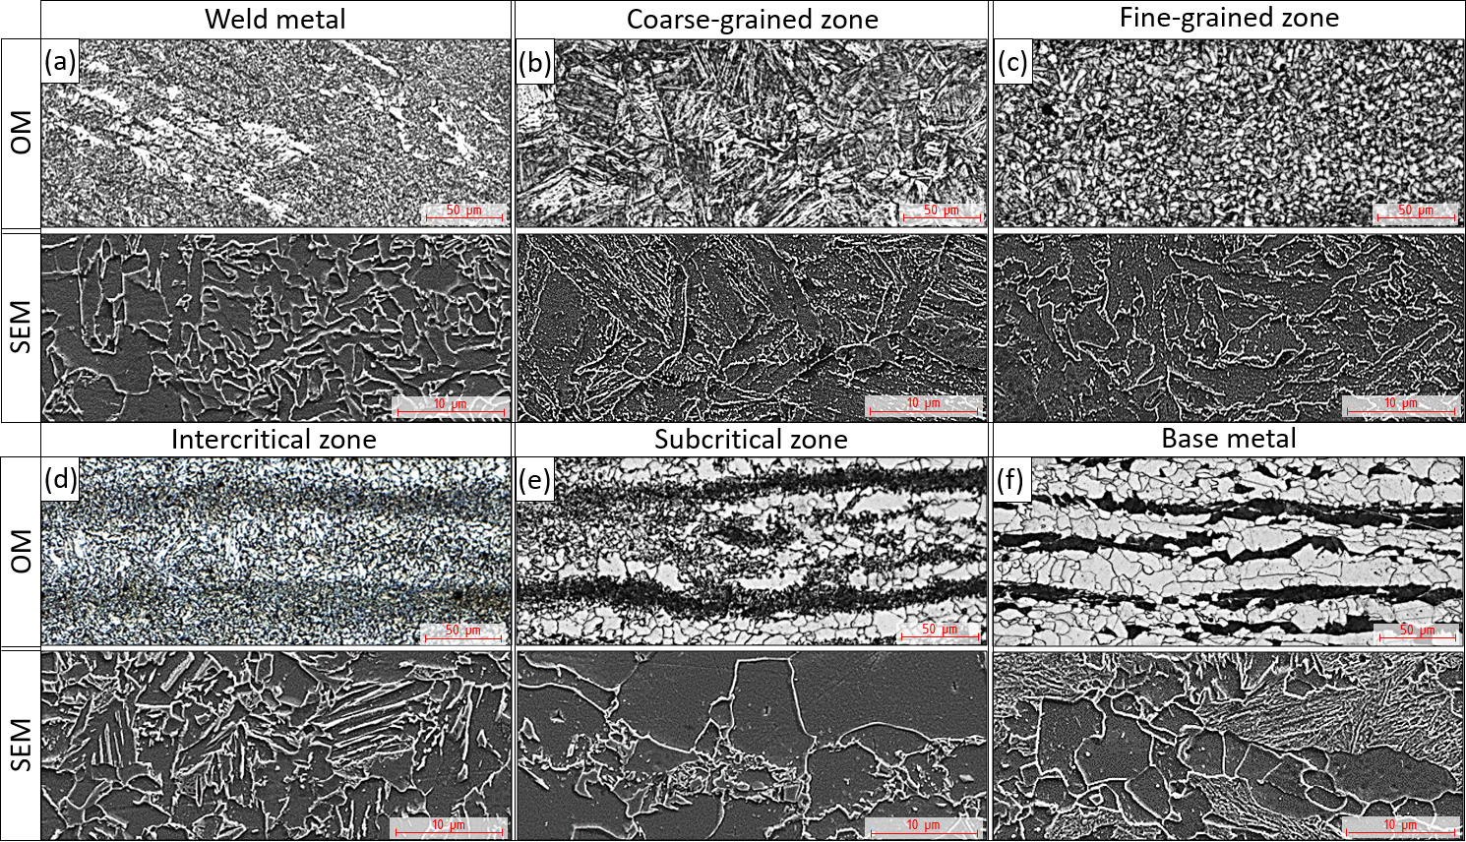

Fig.8 - Microstructure across the P460NL1 welded joint: weld metal (a), coarse-grained HAZ (b), fine-grained HAZ (c), intercritical zone (d), subcritical zone (e) and base metal (f).

Tensile tests of welded joint samples cut perpendicular to the weld were performed in the as-welded and PWHT conditions. In all cases, fracture occurred outside the weld and the measured strength met the required level.
The summarized tensile properties of welded joint obtained for both conditions are presented in Tab. 4.
Tab. 4 - Summary of P460NL1 welded joint tensile properties.

TENSILE PROPERTIES OF P460NL1 WELDED JOINT (MIN–MAX/MEAN)
Delivery condition | Yield strength, ReH [MPa] | Tensile strength, Rm [MPa] | Elongation, A₂₀₀ [%]
As-welded | 452–453/452 | 631–632/631 | 21–22/21
PWHT | 465–468/467 | 608–613/610 | 22–23/22

Segmented impact testing was conducted in the weld metal, at the fusion line and at distances of 2, 5 and 20 mm from the fusion line. The lowest values were recorded at FL+2 mm, while the average impact energy at the fusion line reached at least 186 J at -40 °C and 88 J at -50 °C (Fig. 9).

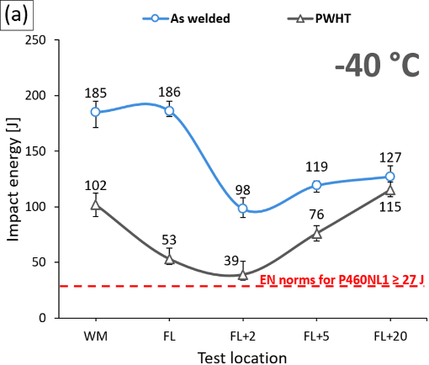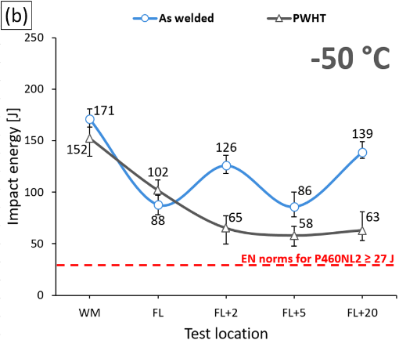

Fig.9 - Impact energy at critical points of the P460NL1 V-shaped welded joint after automatic submerged arc welding: -40 °C (a) and -50 °C (b).

Hardness measurements showed higher values in the weld metal and fusion line than in the base metal, but all results remained within the acceptable range. The average HAZ microhardness was approximately 280 HV0.3 and the maximum individual value did not exceed 323 HV0.3. The local maxima were associated with the overheating cycle near the fusion line (Fig. 10).

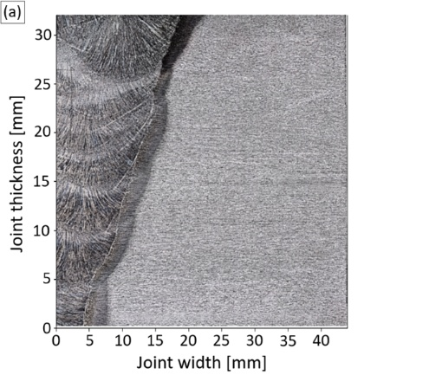

Fig.10 - Microhardness distribution in the P460NL1 welded joint: macrostructural overview (a) and HV0.3 heat map (b).

Controlled thermal severity (CTS) and bead-on-plate (BoP) tests were used to assess cold-cracking sensitivity and local HAZ hardening. In the CTS test, no cracks were detected and the maximum HAZ hardness did not exceed 285 HV5. In the BoP test, macrostructural analysis revealed no defects in the weld metal or HAZ, while the maximum HAZ hardness was 262 HV5 (Fig. 11).

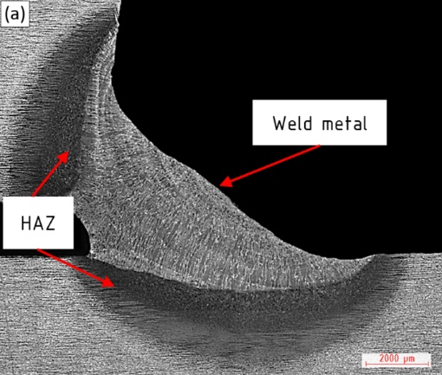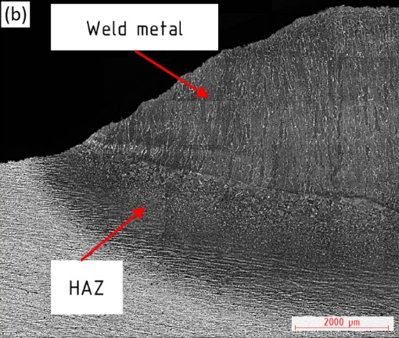

Fig.11 - CTS (a) and MIG BoP (b) weldability tests of P460NL1.

CONCLUSIONS

The investigated steels, developed by NLMK DanSteel with positive industrial results, represent two relevant material concepts for mobile pressure vessels in liquefied CO₂ applications.
P355NL2 supplied in normalized condition demonstrated stable plate-by-plate heat treatment parameters, a homogeneous ferrite-pearlite structure, base metal hardness of 156-162 HV10 after normalization and 153-159 HV10 after sPWHT, and a stable reserve of low-temperature toughness. In the P355NL2 welded joint, the maximum hardness was 227 HV10 and minimum average impact energy at the fusion line was 71 J at -45 °C.
P460NL1 supplied in normalized-rolled condition provided a higher strength level and reliable weldability. SAW joints showed a ferrite-bainite base structure with bainitic-acicular constituents near the fusion line, a maximum microhardness of 323 HV0.3 and an average HAZ microhardness of about 280 HV0.3. Average impact energy at the fusion line reached at least 186 J at -40 °C and 88 J at -50 °C. CTS and BoP tests showed no cracking, with maximum HAZ hardness of 285 and 262 HV5, respectively. The higher-strength P460NL1 route is therefore suitable for structures where reduced wall thickness and vessel weight are required.
The obtained results enabled successful certification according to Bureau Veritas rules NR 216 and NR 467.

REFERENCES

- European Commission. Industrial Carbon Management Strategy. COM(2024) 62 final. Brussels: European Commission; 2024.
- Mac Dowell N, Fennell P, Leeson D, Shah N. Feasible deployment of carbon capture and storage and the energy transition in Europe. Nat Clim Chang. 2024;14:731-742. https://doi.org/10.1038/s41558-024-02104-0.
- Roussanaly S, Deng H, Skaugen G, Gundersen T. At what pressure shall CO₂ be transported by ship? An in-depth cost comparison of 7 and 15 barg shipping. Energies. 2021;14:5635. https://doi.org/10.3390/en14185635.
- CLIMIT. Technology Qualification of Low-Pressure CO₂ Ship Transportation. Oslo: CLIMIT; 2022.
- Pérez-Bódalo E, d’Amore-Domenech R, Leo TJ. CO₂ marine transportation from a techno-energetic perspective. J Mar Sci Eng. 2024;12:12. https://doi.org/10.3390/jmse12010012.
- Rackley SA. Carbon Capture and Storage. 2nd ed. Oxford: Elsevier; 2017. 698 p.
- Adamiec J, Urbańczyk M, Głowik K, Boryczka M, Majzner M. The combined welding of advanced steel P460NL2 mod. used in railway tanks. Biul Inst Spawalnictwa. 2020;4:25-34. https://doi.org/10.17729/EBIS.2020.4/2.
- Goli-Oglu E, Filatov A, Tufaru E, Coghe J, Mouton J. Weldability investigations of low carbon microalloyed heavy plate steel grade P460NL1 for liquid CO₂ storage tanks. Steel Res Int. 2026;97:e2500633. https://doi.org/10.1002/srin.202500633.
- Wagenborg. First CO₂ tanks installed on Carbon Destroyer 1 - a major milestone in Europe’s flagship CCS project [Internet]. Available from: https://www.wagenborg.com/news/first-co2-tanks-installed-on-carbon-destroyer-1-a-major-milestone-in-europe-s-flagship-ccs-project.
- Sarkits I, Bokachev Y, Goli-Oglu E. Production of heavy plates on the rolling mill 4200 NLMK-DanSteel A/S. Stahl Eisen. 2014;134(4):57-61.

