**Blast Furnaces CO2 mitigation: Ekofor technology (E.S.C.H. gmbh) for BLUAIR injection (Secondary Raw Material - recycled polymers)**

**Elia Gosparini – I.Blu srl, Italy**

**Daniel Kaulbars – E.S.C.H. gmbh, Germany**

In steelmaking, integral cycles will face important investments for decarbonization, that will hardly get paid in the short term due to market outlook (dumping, weak border barriers, high energy costs…). In this context, ESCH and I.Blu are cooperating in some BFs ensuring reliable and continuous injection of BLUAIR, a high quality Recycled Raw Material deriving from polyolefin-based feedstock comprised of domestic household plastic waste, which enables an immediate cut of 20-30% CO2 reduction on the direct emissions coming from coal (PCI) injected from BF tuyeres. BLUAIR’s Hydrogen content (about 12%) and its Lower Calorific Value (about 35MJ/kg compared to 26-28MJ/kg of PCI) are also beneficial to the reduction process in the BFs. BLUAIR is widely available, already spread across the market, and can decrease by about 20% PCI consumption in Blast Furnaces. ESCH gmbh has been the first company in Europe to engineer, in addition to traditional PCI injection plants, a tailor-made injection equipment for alternative reductants in Blast Furnaces, named Ekofor, which is able to provide a flexible and affordable injection solution with a low “time to market” approach and low payback period, which can guarantee stable KPIs on the process. PCI plants and Ekofor injection technology for polymers can be flexibly adapted to improve BF Process and OPEX costs for raw materials. Ekofor injection plant is available as follows:

* Ekofor Pilot plant: is a flexible, plug and play, rental solution which is able to allow receival of BLUAIR in loose form, load a tailor-made vessel distributor designed with 3 outlets, and guarantee a low injection rate around 1,5-2ton/h depending on BF operation, allowing approximately -10kgCO2/tonHM for AVG BF
* Ekofor Industrial plant: reliable, affordable and industrial solution which can guarantee a higher controlled injection rate of BLUAIR, 25 to 50 kg/tonHM, replacing 20% of PCI injected, equal to -50kgCO2/tonHM for AVG BF

**KEYWORDS:** DECARBONIZATION – BLAST FURNACES – WASTE PLASTICS – SECONDARY RAW MATERIAL POLYMERS – PULVERIZED COAL INJECTION – pilot plant – NO CAPEX

**INTRODUCTION: EUROPE’S STEEL INDUSTRY UNDER PRESSURE: BACK TO OLD AND RELIABLE TECHNOLOGIES**

The iron- and steel-making sector in Europe represents one of the pillars of the heavy industry economy, counting more than 80B€ sustaining GDP and more than 2,5M of workers. The European steel industry is facing acute challenges in the next years, caught between surging production costs, tough global competition, and the ambitious and complex push toward carbon neutrality. While the EU's **decarbonization** agenda remains a key point of industrial policy, its implementation risks undermining the sector’s competitiveness. A combination of skyrocketing energy prices, expensive emissions regulations, and sluggish demand is placing enormous strain on steelmakers. As a matter of fact, CBAM introduces new uncertainties and potential disruptions in both domestic and international markets, electricity and gas prices in Europe remain significantly higher than in competing regions, especially the U.S. and Asia, phasing out of free allowances by 2034 under ETS reforms is projected to expose European steelmakers to €14 billion in direct costs by 2030 ([EUROFER](https://european-steel.eu)). Despite EU targets, the transition to carbon-neutral steel is stalling. Green hydrogen-based steel production remains marginal, and major players such as ArcelorMittal and SSAB have delayed or rejected large-scale projects, due to high and unstable energy costs ([Arcelormittal](https://www.reuters.com/sustainability/climate-energy/arcelormittal-drops-plans-green-steel-germany-due-high-energy-costs-2025-06-19/?utm_source=chatgpt.com)).

In this scenario, concerning and challenging at the same time, the industry is forced to look back at old and reliable fossil-based technologies, i.e. coal and its derivatives, while the Blast Furnace phasing-out roadmap is actually slowing down. Among the technologies for **Blast Furnaces**, it is worth mentioning a hybrid solution between carbon neutrality and fossil-based route, which is cost effective and sustainable at the same time: the Polymer Injection Technology (PIT) for Blast Furnaces, a reliable, efficient and sustainable buffer solution which could help the Iron Industry to face the current challenges.

**POLYMER INJECTION TECHNOLOGY (P.I.T.): HISTORICAL MENTIONS**

PIT is not a new groundbreaking novelty among the technologies available in the sector. It’s been used in BFs trials since 2000s with the injection of so called “**waste plastics**”.

**Tab. 1** – Blast Furnace and “waste plastics”. Source: (Carpenter, 2010)

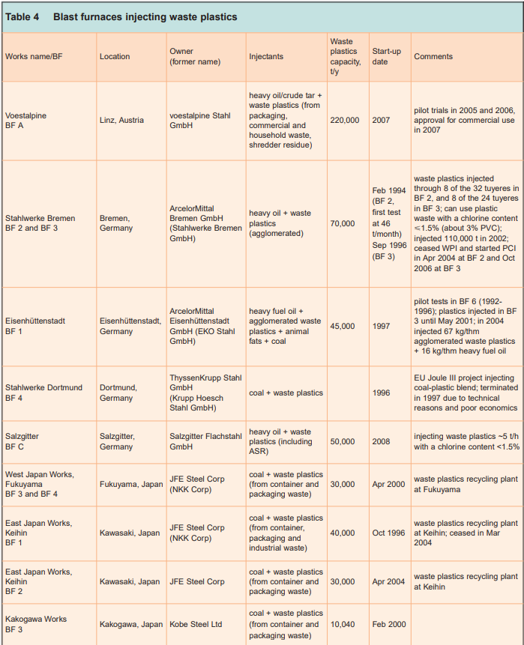

In the years 2000s, funds have been raised from government, in particular in Germany, to use waste plastics in hot processes like BFs, which used to receive funding to use them as secondary reducing agents, with gate fees for final users up to 250€/ton depending on the process (Tukker et al., 1999)

Unfortunately, as far as market was funded by government, the production technology linked to “Waste Plastic (WP)” preparation for BFs did not develop and as soon as funding was interrupted, the usage of WP stopped. Apart from a couple of isolated cases that continued to inject WP in replacement of fossil sources, all the projects were suspended.

**THE VALUE OF PAST EXPERIENCE: ROADMAP FOR FUTURE DEVELOPMENTS**

At present time, there is neither any funding scheme for final users of WP nor for the preparation and production of waste-based reducing agents, meaning that the R&D on the materials properties and on the equipment needed to process those materials have not been significantly advanced. Nowadays, considering the market situation and the overall challenging scenario for the industry, past experience needs to be taken as a starting point to further develop a **bridge solution** to a net zero emission steel industry.

**From “Plastic Waste (PW)” to “Secondary Raw Material Polymers (SRMP)”**

The Plastic Waste that was used in the early 2000s were the result of very basic treatments, consisting of few mechanical steps, which resulted in hard-to-process physical properties as well as higher levels of pollutants and heavy metals.

For instance, there were few or no sorting steps of the feedstock, and low temperatures pelletizing processes, as also reported by JFE (Yoji et al., 2001).

Yoji et al., 2001).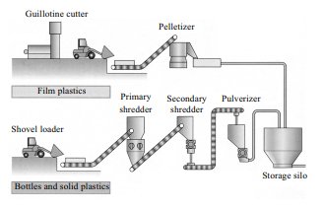

Figure 1 Equipment for conversion of industrial waste plastics to blast furnace material in 2000s (Source: Yoji et al., 2001).

Only one kind of de-chlorination process has been developed through a high temperature extrusion. On the other hand, high temperature extrusion (320°C) starts decarbonizing and degradating polymers, and implies high energy consumptions, leading to a anti-economical solution.

Figure 2. Schematic diagram for pulverization of waste plastics (Asanuma et al., 2014).

Thus, producers of WP were only producing these plastics as a “by-product”, and as soon as the funding for this market were interrupted, these flows have been discontinued and instead landfilled/incinerated in WTE plants. Also, since the early 2000s, the physical shape of plastic waste used as reducing agents in BF has developed. It began with a rough pelletized shape as followed in Figure 3.

Figure 3. agglomerated waste plastics (source: (Nomura, 2015)

The type of waste-based materials showed in Figure 3 are hard-to-transport physical shapes, are not homogeneous and contain non-densified fractions which contribute to low pneumatic transportation capabilities. Clogging and irregular conveying were detrimental consequences of this rough and unprocessed physical shape.

In recent years, the industry has been working on improving both the physical shape and chemical composition of the reducing agents, in order to re-introduce the use of recycled polymers in BFs operations. Chemical composition (which represents the major obstacle on the WP usage in BFs) can be widely controlled thanks to the combination of new technologies like advanced optical/infrared readers and especially by having better control on the supply chain of the feedstock of the recovery activity deriving from the separate collection. Also the physical shape has been improved, investing in specific densification/agglomeration equipments as well as specific milling and sieving systems in order to obtain the best physical properties in terms of flowability and pneumatic transportation properties in the pressure vessels, pipes and valves through the whole pipeline. This can be achieved only by focusing on the steel making industry as the target field of application: treating it as the “Core Business” and not anymore a “by-product” to get rid of.

A virtuous example of PW transformed into “**Secondary Raw Material Polymers**” is BLUAIR®, produced from I.Blu, a company focused on supplying recycled plastic products to various industries like the iron and steel making sector, in replacement of coal and its derivatives. In particular, I.Blu has developed the state-of-the-art recycling of heterogeneous plastics waste resulting from the end of the sorting line of collected packaging waste from domestic households, achieving low pollutant levels and high physical properties. This has been possible thanks to the control of the whole supply chain, form the collection to the sorting and the recycling process of the plastic feedstock, and to the fact that the product application in the iron and steel making industry represents the **Core Business** of the company.

With Recycled Polymers like BLUAIR®, for instance, the technological obstacle of chemical composition and physical shape has been overcome, making its use in BFs more interesting and better performing compared to the 2000s. Following in Figure 4 an example of improved physical shape, thanks to Secondary Raw Material treatments

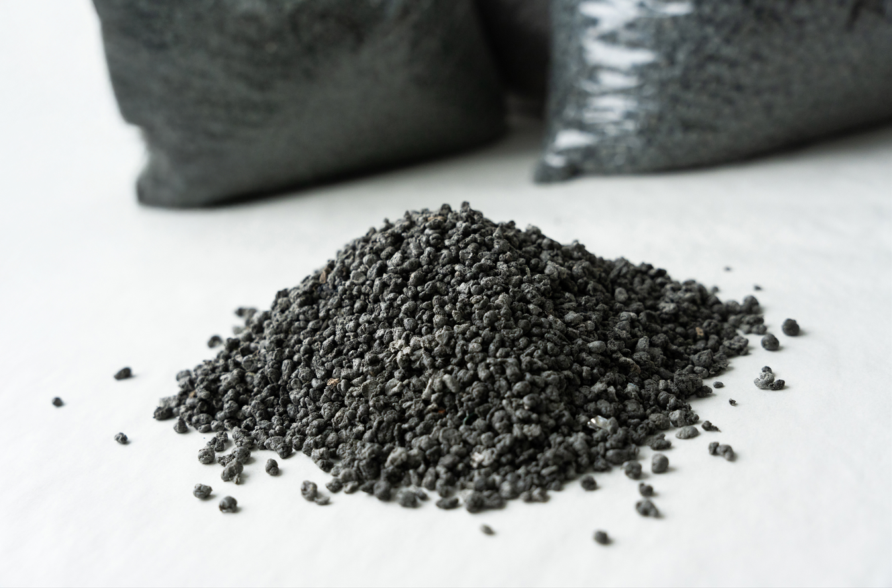

Figure 4. Secondary Raw Material polymers (source: www.iblu.it)

**Handling equipment supplier: from single industrial solution to flexible tailor-made proposals**

In order to inject the polymers into the blast furnace, special technology is required which is also based on dense phase conveying technology, but differs in detail from classic **Pulverized Coal Injection** technology. The main difference lies in the distribution technology. In polymer injection, it is not possible to work with the static distributors used in PCI technology, which requires the use of a special injection vessel to distribute the polymers to several tuyeres. This injection vessel must be designed in such a way that it allows the polymers to be fed into the small single conveying lines while the distribution vessel is under overpressure of up to 6 bar(g). This requires special components for mechanical and pneumatic loosening of the material. The company E.S.C.H. GmbH (ESCH) developed this industrially proven technology in the late 1990s and has successfully implemented it in Salzgitter, Bremen, Eisenhüttenstadt and Linz in different applications.

A fully equipped polymer injection plant for an annual injection capacity of 50 - 200 kt is a state-of-the-art equipment since over 20 years but the industrial turn-key solution requires high investments cost of about 10-20 Mio. €. Thanks to fundings in the past with the aim reducing plastic waste in Europe and substitute heavy oil it was easy to establish industrial plants getting a return on invest within 2 - 3 years operation cycle. Because the framework conditions for promoting and funding such plant technologies are currently very difficult, and thanks to the evolution of the Raw Materials to be injected such as **SRMP**, it is necessary to think about smart flexible and durable solutions. With the target of industrial equipment, it is also important to think about pilot solutions to let customers try the material show the feasibility of SRMP injection for their individual BF process providing a **low injection rate solution**. An example of adaptation to this market conditions has been provided form ESCH has designed a pilot solution using rental for customers basing of the layout of the PCI plants, shown in the following flow chart for the Polymer Pilot Injection Plant.

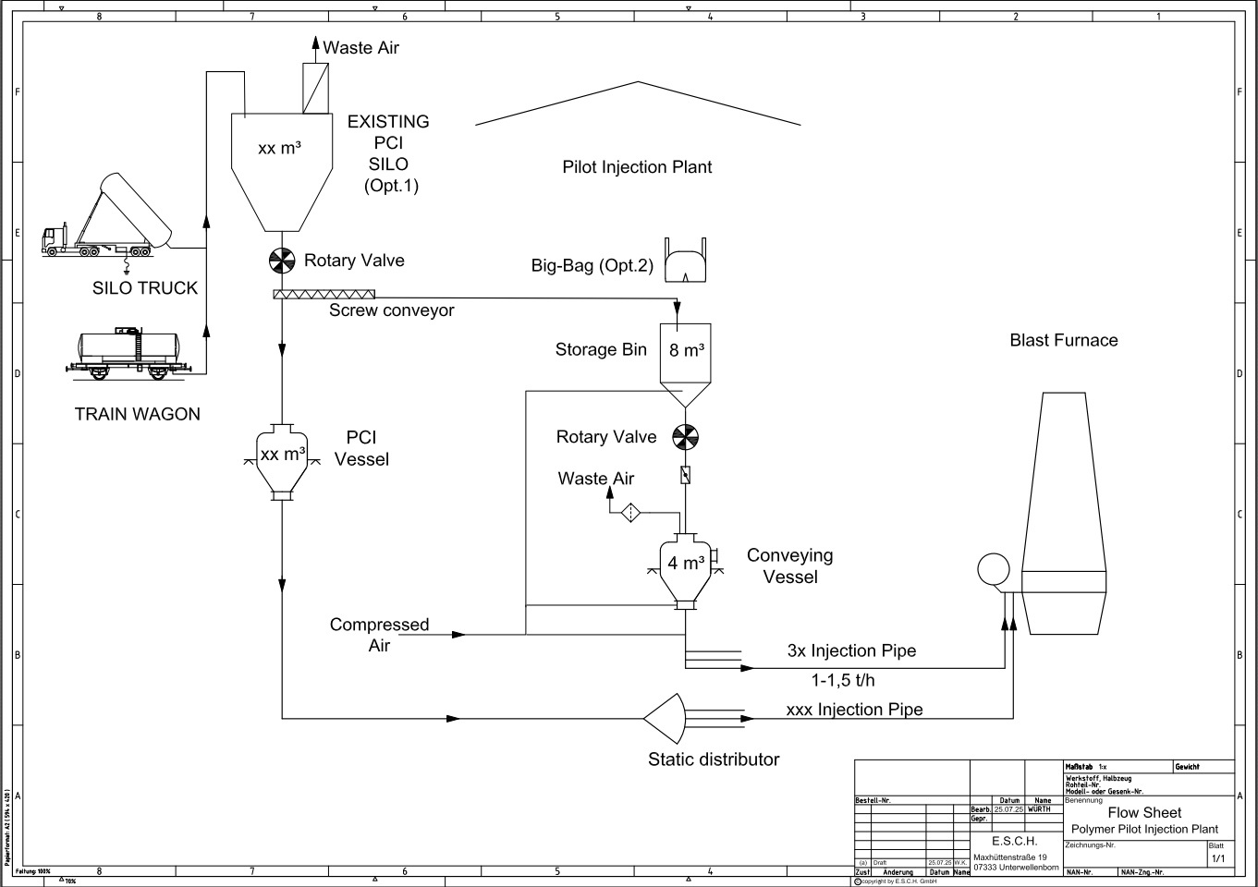

Figure 5. Schematic pilot injection plant configuration

A The mobile solution can be set up on the day of delivery and put into operation within a few hours. The injection lines should be evenly distributed around the furnace and the longest line must not exceed 150 m. The conveying medium is compressed air (6-10 bar(g)) and must be provided by the customer from the factory network. It is equipped with an automation and control system that automatically refills the injection vessel and regulates the injection rate. The refilling of the storage bin can be organised in two different ways: either manual refilling with big bags or filling from an existing customer silo (e.g. PCI silo from existing installation). The conveying vessel must be depressurised in order to be filled, which means that continuous injection is not possible as it is briefly interrupted during refilling.

The scale-up version of the polymer injection system shown in the following flow chart primarily ensures continuous injection.

Figure 6. Schematic SRMP scale up indistrial configuration

This solution makes sense if the basic feasibility of polymer injection has been confirmed and a continuous supply of material for injection can be guaranteed. Two different variants can also be implemented for delivery and supply: either pneumatic unloading from silo vehicles and trains into a silo (option 1) or mechanical unloading from push-floor/walking floor trucks (option 2). From the unloading system and intermediate storage, the polymer is conveyed pneumatically to the injection tower, where it is temporarily stored in a small storage bin. The integration of a pressure lock hopper ensures that the conveying vessel can be filled without depressurization during the continuous injection process. As a result, the effective injection rate is significantly higher than in the pilot plant, meaning that also more tuyeres can be supplied. This scale up plant configuration is also movable, meaning that the plant components can be dismantled if necessary and again reassembled at another blast furnace or even at another BF plant within the group. However, the erection efforts are higher than for the mobile pilot plant and this equipment is not possible for rental solution.

**BENEFITS OF POLYMER INJECTION TECHNOLOGY**

**Technical Benefits**

The higher quality standards achieved thanks to the pre-treatments and agglomeration with respect to the past operations, compared to the use of waste as-is, enables:

* Higher PCI substitution rates due to agglomeration and better mechanical properties
* More continuous and stable injection in time, thanks to physical and chemical homogeneity
* Better chemical composition: higher concentration of recycled carbon and hydrogen , lower content of undesired substances (e.g. heavy metals), low sulphur content (about 50% to 80% less compared to PCI)

The substitution rate of PCI (between 170 and 190kg/tonHM) can be estimated between 20% (35kg/tonHM) and 40% (70kg/tonHM). Under an European perspective, a conservative 10-20% substitution of the PCI quantities currently injected in BF route with recycled polymers, from 1,6MLNton/y to 2,8 MLN ton/y of virgin coal can be substituted, generating substantial environmental and economic benefits.

**Environmental benefits:**

Virgin fossil materials are preserved and kept in the ground, as they can be replaced by the recycled carbon and hydrogen contained in the Secondary Raw Material Polymers. The substitution of coal reduces the impacts related to their extraction, long-distance transportation and refinement of virgin coal (PCI and anthracite).

The LCA study performed by Rina CSM within the European RFCS project Onlyplastic confirmed that there is an emission saving linked to the avoided incineration of plastic waste streams that are hard-to-recycle in plastic-to-plastic applications (i.e. flexible multilayer food-packaging) but can still be recycled to be used in steelmaking (Bissoli et al., 2025; RINA CSM, 2023).

Moreover, emissions are saved in the steel production cycle, both in EAF and BF.

CO2 emissions are cut down thanks to:

* the reduced use of coke and other reducing agents (e.g. PCI) in Blast Furnaces, the production of which represents one of the most impactful phases in steelmaking, as also reported by the JRC BAT Reference document for Iron and Steel (Remus et al., 2012);
* process emissions reduction: according to national standard emission factors (German Environmental Agency, 2022.; ISPRA, 2024), and considering a PCI substitution ratio of 1:0,75 (as stated in the JRC report), about one tonne of recycled polymers (BLUAIR®) can save about 20%-30% in terms of the CO2 emissions related to the injection of reducing agents. Moreover, according to the JRC study, plastic injection can generally improve the productivity and performance of the steelmaking process (Remus et al., 2012).

Based on the research carried out in Voestalpine Stahl GmbH between 2008 and 2011 on the use of waste plastics (WP) in blast furnaces, the contaminants that deserve the most attention are heavy metals (especially Cd, Hg, Pb, and Zn), Sulphur- and chlorine-based compounds (Trinkel et al., 2015). According to the monitoring data of the plant, it was concluded that the input loads of heavy metals were efficiently retained by the filter and cleaning devices in place, and at a WP injection rate of 35 kg/t HM, the concentrations of heavy metals in the output flows and emissions remained unaffected.

Pre-treatments of WP, such as cleaning, de-chlorination and homogenization (Ahmed, 2018), are recommended to avoid formations dioxins, the build-up of non-ferrous heavy metals, and the corrosive effect on the tuyeres due to chlorinated plastics. Regarding SOx, previous studies have already reported lower Sulphur content after WPI implementation, with emission levels consistently remaining within statutory environmental regulations (Carpenter, 2010).

With regard to the innovative technology presented in this document, further cleaning and agglomeration of the plastic waste through a recycling operation is necessary to guarantee low levels of chlorine and heavy metals. Moreover, the data collected show that these treatments enable to have Sulphur content about 50%-80% lower than the one contained in virgin coal.

**Economic benefits**

Thanks to lower purchase costs compared to coal and CO2 emission reduction (EU ETS), savings are possible.

For example, hereunder the savings for a plant that substitutes 60.000 ton/y of PCI with 80.000ton/y of recycled polymers are estimated:

* Material value savings equal to about 100€/ton compared to coal (about 4MLN€/y);
* Additionally, about 20.000ton/CO2 are avoided in EU-ETS → additional saving of about 1,3 MLN€/y – 3,9MLN €/y .

**CONCLUSIONS:**

Considering the challenges both under economical and technological point of view, decarbonization pathway is resulting more costly and complicated compared to very first assumptions. A bridge solution can definitely be the Polymer Injection Technology (PIT), focused on SRMP (e.g. BLUAIR®) and reliable and flexible injection plants (e.g. ESCH gmbh pilot plant solution), allowing the immediate and reliable PCI replacement with a sustainable Secondary Raw Material Polymer, an immediate CO2 cut, savings in purchasing compared to traditional fossil sources and an under control process under the POV of pollutants and pneumatic transportation conditions.

**REFERENCES**

Ahmed, H. (2018). New trends in the application of carbon-bearing materials in blast furnace iron-making. *Minerals*, *8*(12). https://doi.org/10.3390/MIN8120561

Asanuma, M., Terada, K., Inoguchi, T., & Takashima, N. (2014). Development of waste plastics pulverization for blast furnace injection. *JFE Technical Report*. https://www.researchgate.net/publication/288320564_Development_of_waste_plastics_pulverization_for_blast_furnace_injection

Bissoli, M., Malfa, E., Marchesan, E., Sante, L. Di, Casa, M., Frittella, P., & Salas, L. (2025). Multi-material injection system to foster circularity: Valorization of recycled polymers from waste plastics in electric arc furnace. *Thermal Science and Engineering Progress*, *61*, 103497. https://doi.org/10.1016/J.TSEP.2025.103497

Carpenter, A. M. (2010). *Injection of coal and waste plastics in blast furnaces*.

German Environmental Agency. (n.d.). *CO2 Emission Factors for Fossil Fuels | Umweltbundesamt*. Retrieved December 12, 2024, from https://www.umweltbundesamt.de/en/publikationen/co2-emission-factors-for-fossil-fuels-0

ISPRA. (2024). *EU ETS - Pubblicazione parametri standard nazionali anno 2023*. https://www.ets.minambiente.it/News#427-pubblicazione-parametri-standard-nazionali-anno-2023

Nomura, S. (2015). Use of Waste Plastics in Coke Oven: A Review. *Journal of Sustainable Metallurgy*, *1*(1), 85–93. https://doi.org/10.1007/S40831-014-0001-5/FIGURES/17

Remus, Rainer., Roudier, Serge., Aguado-Monsonet, M. A. ., & Delgado Sancho, Luis. (2012). Best Available Techniques (BAT) Reference Document for Iron and Steel Production Industrial Emissions Directive 2010/75/EU (Integrated Pollution Prevention and Control). *JRC Publications Repository*, 597. https://doi.org/10.2791/98516

RINA CSM. (2023). *EAF working with SRA derived from plastic residue in substitution of fossil fuel; Deliverable 7.1 - LCA Assessment and comparison with current practice-based coal use*.

Trinkel, V., Kieberger, N., Bürgler, T., Rechberger, H., & Fellner, J. (2015). Influence of waste plastic utilisation in blast furnace on heavy metal emissions. *Journal of Cleaner Production*, *94*, 312–320. https://doi.org/10.1016/J.JCLEPRO.2015.02.018

Tukker, A., de Groot, H., Simons, L., & Wiegersma, S. (1999). Chemical Recycling of Plastic Waste (PVC and other resins). *TNO Institute of Strategy, Technology and Policy*.

Yoji, O., Koichi, T., Atsushi, W., & Koji, A. (2001). Recycling of waste plastic packaging in a blast furnace system. *NKK Technical Review*. https://www.researchgate.net/publication/289445458_Recycling_of_waste_plastic_packaging_in_a_blast_furnace_system