Italian Association for Metallurgy

COPYRIGHT ASSIGNMENT STATEMENT

This document is for the copyright assignment of original contributions submitted to the Conference

7h ESTAD 2025 Conference

1. COPYRIGHT ASSIGNMENT 1.1 The undersigned transfers to AIM the copyright of the Contribution, in the form of FULL PAPER, submitted to the Conference (7th ESTAD 2025) as described above, claiming to be its author. By Contribution, it is meant: (a) the work presented for the Conference (7th ESTAD 2025) (b) any written material or media file used in connection with the work itself; (c) any recorded speech. 1.2 The transfer of copyright includes: a) the publication, use, copy, distribution of the contribution in all its forms (including digital and electronic format); b) the translation in other languages, the review or collection in monothematic collections, in printed or electronic format; c) the assignment to third parties of the same rights for reprinting, republication or other types of use. AIM can also publish extracts, summaries or translations of its own publications.

2. RELEASE AND APPROVAL 2.1 The undersigned guarantees that: a) the Contribution is original and has never been used, in any language, in other Conferences/Journals. b) the data collected and presented in the Contribution are original and reliable; c) the content of the Contribution is not in any way obscene or libelous, it doesn’t violate privacy rights or rights of the ownership protection (including copyright, patent or trademarks), nor violates any human or personal right; d) to have not violated any confidentiality right, that it might be compelled to, nor any agreement; 2.2 If the Contribution contains parts of other published works or it was done with the creative contribution of different subjects too, the undersigned declares to have obtained formal authorization for the use.

3. TERMS AND CONDITIONS 3.1 The undersigned declares to be fully entitled to sign this document and raises AIM from any damage or expense resulting from the violation of any of the above-mentioned declarations. 3.2 In the event that the Contribution is not accepted or published by AIM, or it is withdrawn by the Author, this document will be null and void.

The undersigned signs on behalf of all the other possible authors of the Contribution:

Family name and Given Name: ROBERTO CONTE

Place and date: > TAVAGNACCO, 25.07.2025

Signature:

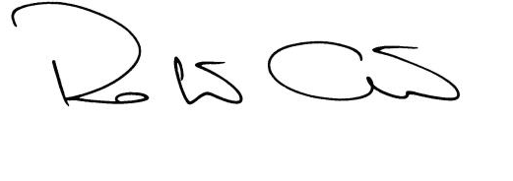

This document should be filled in, undersigned and uploaded together with the full paper.

Each request on this regard can be addressed to the Secretariat of the Italian Association for Metallurgy: (estad2025@aimnet.it).