**FLEXIBLE PATHWAYS TO GREEN IRON PRODUCTION**

**Massimiliano Zampa – Danieli Centro Metallics, Italy**

**Marco Lapasin – Danieli Centro Metallics, Italy**

**Deepak Verma – Danieli Corus, The Netherlands**

**Edo Engel – Danieli Corus, The Netherlands**

*Against the background of our industry’s decarbonization, iron production is as essential topic for the steel industry and the availability of raw materials (e.g. technological requirement for virgin iron units when producing certain steel grades and – lagging - scrap availability in emerging economies) are two main driving forces.*

*Traditional, carbon-intense production route can be substituted with cleaner pathways and hybrid plant configurations combining different production routes (DRI, EAF, BF and/or BOF) and different reduction agents/sources of energy represent the main challenge for owners and operators of existing large-scale steel plants.*

*This article presents technical as well as logistical challenges connected to these hybrid configurations as well as their benefits and bottlenecks with respect to operating cost and carbon footprint.*

**KEYWORDS:** Decarbonization, sustainability, direct reduction, blast furnace

**INTRODUCTION**

As the consequences of greenhouse gas emissions are becoming evident, the urgency for the steel industry to reduce these CO2 emissions cannot be underestimated. With steel production being accountable for 7–9% of global CO2 emissions, the time has come for the industry to act. With their inherently favorable carbon footprints, Direct Reduction Ironmaking and Electric Arc Furnace Steelmaking are inevitably going to represent an increasing share in global steel production capacity.

There are, however, challenges when implementing these process under certain conditions:

* Green electricity  
  Many solutions presented to our industry depend highly on the availability of green electricity. It is important to note that majority of steel is produce in regions where the electricity grid carbon intensity is very high and green electricity is not available.
* Hydrogen infrastructure  
  The application of hydrogen as a reducing gas is undeniably the holy grail of green steel. However, the absence of infrastructure and elevated production cost will continue to be prohibitive in many cases;
* High–grade ores  
  With less than 10% of global iron ore shipments being acceptable as feedstock for Direct Reduction Ironmaking, the corresponding grades will become increasingly sought–after, with obvious consequences for cost. Alternatively, lower grade ores can be processed, but the resulting DRI imposes challenges downstream;
* Carbon capture and storage  
  It is projected that by 2030, global Carbon Storage capacity will amount to approximately 1.25% of global CO2 emissions. In total, 1% of this capacity will be allocated to steel production, corresponding to roughly 0.2% of steelmaking CO2 emissions. Relying on the availability CCUS capacity represents an unacceptable risk and
* Technology readiness  
  Implementation of a technology that has yet to be proven or that needs to go through its scale–up phase is associated with risks that are in conflict with the objective of achieving the required emission reduction by 2030. An example is the application of electrical melting concepts, such as the Submerged Arc Furnace or Brush Arc Furnace, for large–scale processing of DRI produced with lower ore grades.

We consider the DRI–EAF production route, using natural gas as a reduction gas in the DRP, the base line for proven green steel production processes and, as such, the baseline for development targets related to the traditional integrated route. With its typical 40% lower CO2 emissions in comparison to the traditional BF–BOF route, realizing this development target would represent a great step forward in steel industry decarbonization given the scale, at which this can be applied. Any lower emission level will inevitably have to be result of improvements in the area of DRI and/or EAF.

**GLOBAL STEELMAKING GREENHOUSE GAS EMISSIONS**

As mentioned above, our industry is accountable for 7–9% of global CO2 emissions. Since the cost of energy and metallurgical coke are large drivers for cost per tonne of steel, our industry has been shifting towards carbon–lean production for decades. Current emission levels for each production route represent a techno–economic equilibrium, as is common in mature industries. Typical ranges for the emissions of greenhouse gases for each route are illustrated below; we recognize that though the typical as well as best–in–class emission levels are generally well–defined, we assume ranges of emission levels since some steel producers experience operating conditions that prohibit operating at these best–in–class or even typical levels, e.g. owing the availability of only low grade ores.



**Fig. 1** – Emission levels for main steel production routes

We have established a reference case for CO2 emissions related to BF–BOF steelmaking to support the development of alternative scenarios. Within this base case, it is evident that most emissions emanate from the Blast Furnace section.



**Fig. 2** – Emission levels per area for BF–BOF steelmaking (reference case)

**FUTURE SCENARIOS**

For the decarbonization of steel production, we identify three realistic scenarios:

* DRI(–EAF) on either natural gas or hydrogen; we will elaborate on how the flexibility of Direct Reduction Ironmaking accommodates some of the challenges experienced when implementing DRI in certain (mainly geographical) areas;
* BF–BOF decarbonization; with the 1200 kgCO2/tCS baseline established based on (traditional) DRI–EAF production, we will present a realistic scenario for reducing BF–BOF steelmaking CO2 emissions with 40% and
* Hybrid configurations; combining DRI, EAF, BF and BOF production units within a single site is not only inevitable, such hybrid configurations represent hidden benefits.

The authors are of the opinion that many other scenarios presented in our industry are not realistic given their inherent inability to overcome the challenges discussed in the introduction section of this article.

**Energiron: the flexibility to use a variety of input gases**

Within the available direct reduction technologies, ENERGIRON – the innovative DRI technology jointly developed by Tenova and Danieli – stands out for being capable to use a unique and well consolidated process in a wide range of operating scenarios.

This allows to efficiently use the different raw materials available in different locations of the world and to produce high-quality DRI with the characteristics that are required by the end user, which as well may vary from case to case. Finally, this unique technology provides additional value in use to both the operators of ENERGIRON plants and to DRI users.

The same ENERGIRON process scheme can be applied for:

* The production of high quality DRI in any of its commercial forms: cold DRI, hot DRI and HBI. Metallization and carbon content can be easily and promptly adapted to the steelmaking needs. Consistency of DRI quality is the ENERGIRON trademark.
* Processing a wide variety of iron oxides. Not only DR-grade pellets, but also BF-grade and lump ores.
* The usage of any reducing gas rich in hydrogen. Energiron has the unique characteristic to process natural gas of any quality and chemistry, but also hydrogen, syngas, reformed gas, coke oven gas and others…
* Green steel projects to be implemented in phases. The same ENERGIRON plant can operate today with natural gas, which eventually can be replaced by green hydrogen in future, with no changes to the equipment. A carbon capture system is embedded in the ENERGIRON process, therefore up to approx. 60% of the CO2 generated by the reduction of iron ores can be utilized for CCU/CCS applications.

And most importantly, this operational flexibility comes with no compromises on energy efficiency, which allow owners of ENERGIRON plants to take the advantages of lower OPEX! Read more if you want to discover why ENERGIRON has been selected for 11 new projects in the last 4 years.

In modern steel production, technological advancements are paramount to meet the demands of efficiency, sustainability, and quality. Among the pioneering innovations in this field stands the ENERGIRON Direct Reduction Iron (DRI) technology jointly developed by Tenova & Danieli, which is one of the most viable gas-based DR technologies. Renowned for its flexibility and adaptability to different operating requirements, ENERGIRON represents a huge shift in the production of high-quality DRI, characterized by high metallization and adjustable carbon content.

At its core, the ENERGIRON DRI technology embodies a synthesis of cutting-edge engineering and process design. What sets it apart is its remarkable ability to accommodate and integrate diverse qualities of DRI pellets, and to utilize various gases as feedstock through employing natural gas, syngas, hydrogen, coke oven gas or a combination of them, all within a single process configuration that remains unchanged.

**Fig. 3** – ENERGIRON track record

Started in the 50th with plants of small capacity and after the ENERGIRON Alliance, the capacity of the single unit increased up to 2,5 MTY (Cold DRI plant Zero Reformer commissioned by Nucor Steel), largest single-module size at that time, that nowadays is the most requested capacity for the new DRI modules. In the figure above we can also see the major improvements that ENERGIRON Technology introduced to the DR industry.as the most remarkable ones are : carbon capture in the technological circuit, first zero water consumption plant, first pilot plant using 100% H2, use of COG paving the road for greener steel production with improved plant efficiency. The latest plants are all highlighted in green since they are already ready to move from natural gas to 100% H2 as reducing agent.

These unique traits of the ENERGIRON process, allow plants’ adaptability and versatility, ensuring that the ENERGIRON DRI meets the most stringent industry requirements, granting producers greater autonomy in selecting feedstock, which finally results in competitiveness and resilience in facing fluctuations of market dynamics and resource availability, by ensuring consistent and reliable outcomes, irrespective of pellet and gas quality. All these aspects, which are of outmost importance in the modern ironmaking sector, set ENERGIRON as a frontrunner within the DRI Production Technologies.

**The Process**

The ENERGIRON process is designed for converting iron ore into metallic iron using reducing gases in a solid - gas moving bed reactor. Here's a breakdown of the process:

1. **Feed Material:** Iron ore (either pellet or lump ore) is coated and continuously fed into the system.
2. **Alternative Sources of Reducing Gases:** In addition to natural gas of any quality, alternative sources of reducing gases such as hydrogen, syngas, COG (coke oven gas), and other gases can be utilized in ENERGIRON plants while maintaining the same basic process scheme.
3. **Generation of Reducing Gases:** Natural gas is typically used as makeup feed to the reducing gas circuit and reducing gases, primarily hydrogen (H2) and carbon monoxide (CO), are generated through the self-reforming process in the reduction reactor upon contact with the solid material inside the reactor. Cracking and reforming of gases occur due to the catalytic effect of metallic iron.
4. **Humidifier:** allows a fine control of the reforming of methane and carbon deposition in DRI inside the reactor
5. **Iron oxide reduction:** Oxygen is removed from the iron ore at solid state through chemical reactions with hydrogen and carbon monoxide. These reactions produce highly metalized Direct Reduced Iron (DRI). Metallization can be set at the desired value, up to 96%.
6. **Gas recirculation:** to enhance the system’s efficiency, the reducing gas is recirculated in a closed circuit. centrifugal compressors compensate the differential pressure of the circuit and taking advantage of the operating pressure (6/10 barg) of the ENERGIRON process, the electrical energy consumption can be minimized.
7. **ENERGIRON Process Gas Heater:** heats up the gas up to 950 °C. This unit has been developed by ENERGIRON to fit and satisfy the peculiarity of the DR process in terms of reliability and efficiency.
8. **Injection of Oxygen:** Oxygen is injected at the reactor inlet,the resulting partial oxidation of reducing agents with oxygen increases the operating temperature of the process gas entering the reactor up to the level is required for reforming and iron ore reduction.

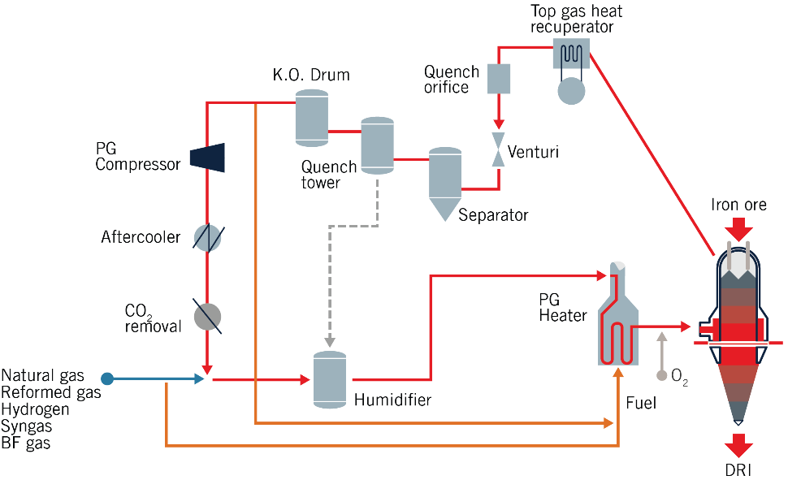

**Fig. 4** – ENERGIRON scheme with and without reformer

**Technological Advantages**

The ENERGIRON technology stands out in the direct reduction (DR) process landscape due to its commitment to energy recovery and efficiency. Here's a breakdown of its key features and advantages:

1. **Iron Ore Pellets Quality:** ENERGIRON Technology is flexible in usingdifferent grades of iron ores including BF pellets. Iron ores with common impurities such as Sulphur and phosphorous, which can be present in some ores in relatively high concentrations, can be used with no limitations in ENERGIRON plants, moreover due to inherent process scheme characteristics, most of the Sulphur of the iron ore is converted to H2S in the reduction reactor and eliminated from the process in subsequent separation steps. This allows using the resources locally available at the most competitive price. Moreover, the high operating pressure of ENERGIRON plants allows to use smaller granulometry iron ores, recovering part of those valuable natural resources that other technologies would discard.
2. **Higher Pressure Operation:** The Operating Pressure (6-8 bar(a) against approx. 2,5 bar(a) for other DR technologies) brings several advantages:
   1. Contain the desired amount of reducing agents in a smaller volume, thus lowering the Process gas velocity compared to other Technologies allows to process also fine materials, that otherwise would be rejected.
   2. Less possibility for gas channeling as the diameter to the height ratio in the ENERGIRON Technology is 1:2 Compared to 1:1.5 in the other Technologies and with less gas channeling, leading to a better and more homogeneous metallization.
   3. proprietary mechanical sealing of the ENERGIRON Reactor increase the safety of the system.
   4. Reduced residence time of iron oxide inside reactor (2 hours instead of 3 hours) allows to boost productivity with a smaller reactor size.
   5. Reduced fines carry-over in the Top gas.
3. **Highest Energy Efficiency:** the outstanding energy efficiency of ENERGIRON plants (typical Natural Gas Consumption of 2.35 Gcal/t) is possible thanks to the proprietary auto-reforming technology and to the use of energy recuperation systems like Top Gas heat recuperator. This equipment optimizes and recovers energy from the sensible heat of process gas leaving the reactor. The recovered heat is used either to produce steam or to preheat the reducing gas before it enters the PGH. By efficiently utilizing this heat, the overall energy consumption of the process is minimized.
4. **Lowest Electrical Energy Consumption:** Since the largest Electrical Load is for the Process gas compressor, operating with High Pressure means higher suction pressure at Compressors inlet leading to smaller Compression Ratio and work done by the compressor helping in minimizing the overall process electrical energy consumption, making the process more energy efficient.
5. **Lowest CO2 Emissions:** Thanks to CO2 removal system embedded in the reduction circuit, ENERGIRON is the best fitted technology to provide CCU (Carbon Capture and Use) and CCS (Carbon Capture and Storage) solutions applied to the steelmaking industry. Among the other possible applications, CO2 generated by ENERGIRON plants is captured and used to produce beverages, conglomerates, dry ice and used in EOR applications with no requirements for additional OPEX and/or CAPEX. This not only helps in minimizing environmental emissions but also provides an opportunity to clean the absorbed CO2 for sale as a by-product.
6. **Highest Quality DRI:** ENERGIRON DRI boasts top-tier quality, enabling steelmakers to optimize overall liquid steel production costs for superior steel grades. The highly metallized DRI with controlled carbon content (ranging from 1% to 4.5%) sets it apart from traditional DRI products.
7. **Efficient Carbon Utilization:** ENERGIRON ZR can produce DRI with any Carbon content, giving to the steelmaker the possibility to go for the most economical mix of chemical and electrical energy input to the EAF. The carbon content, primarily in the form of cementite (Fe3C), is efficiently and completely utilized in the Electric Arc Furnace (EAF). This results in a high yield close to 100%, whereas injected coal and graphite additions typically achieve around 60% yield. The conversion of Fe3C into iron and carbon in the EAF is also an exothermic reaction, further enhancing thermal efficiency and reducing electric power requirements. Additionally, it promotes easy foamy slag generation, akin to adding chemical energy to the EAF. Further efficiencies can be achieved thanks to the proprietary Hytemp® system, a safe and reliable solution to convey the DRI to the EAF at high temperature. This unmatched efficiency of the ENERGIRON technology provides the lowest OPEX and a responsible use of the natural resources.

**Fig. 5** – Carbon in product

1. **Possibility to use various reducing gases:**
   1. Natural Gas with any quality. There is no limitation on the natural gas quality being fed to any of the ENERGIRON Process schemes (ENERGIRON ZR or ENERGIRON IIII). In case of presence of Natural gas with:
      1. high % of heavy parts (like Propene, Butene etc)
      2. High Sulphur content
      3. High N2 Content in the NG

ENERGIRON III Configuration should be used In Case the Above Gas quality is Present. Otherwise, the ENERGIRON ZR Configuration is Proposed.

* 1. Syngas. With similar approach to the Reformed Gas, we can proceed to use also Syngas coming from Coal Gasifier, according to the following scheme:

**Fig. 6** – Plant configuration for Syngas usage

In this case the makeup gas (see below typical composition) coming out from a coal gasifier can be directly use the process circuit, without any major change in the process scheme.

**Tab. 1 –** Make-up gas composition

|  |  |
| --- | --- |
| H2 / CO | > 1,5 (preferred) |
| CO2 | < 3% |
| N2 | < 6% |
| H2S | <100 ppmv |
| Pressure | 13 barg (min) |
| Temperature | Ambient |

* 1. COG (Coke Oven Gas). Traditionally, COG has been viewed as a waste product, often flared off or left unused, contributing to environmental pollution. However, ENERGIRON technology flips this narrative on its head. Instead of letting COG go to waste, it becomes a valuable resource in the steelmaking process. The integration of COG within ENERGIRON technology significantly enhances energy efficiency. COG, rich in carbon monoxide and hydrogen, serves as an excellent reducing agent, aiding in the reduction of iron ore to produce high-quality steel. This not only reduces the reliance on traditional fossil fuels but also lowers greenhouse gas emissions, aligning with global efforts towards sustainability. In this case the process scheme and equipment are always the same, the only difference that the COG is inject in the cone of the reactor where the presence of HDRI assure to destroy the typical impurities of the COG like heavy hydrocarbons, BTX (see typical composition in the table) as per the patented scheme here below:

**Fig. 6** – Plant configuration for the use of Coke Oven Gas

**Tab. 2 –** Chemical analysis Coke Oven Gas



With this configuration today are working the plant of HBIS (0.5 MTY) and Bawou (1 MTY) in China started up in May 2023 and Jan 2024:

The reason why to use COG can be easily explain with the following numbers considering a complex of 4 MTY BF bases:

* Typical we need 350 kg of coke for each ton of hot metal produced.
* For each ton of coke, we can produce 380 Nm3 of COG, so considering the 4 MTY capacity we have the possibility to have 532 MNm3/year of COG.

Now if we consider that:

* For each ton of DRI is need 660 Nm3 of COG, means that with the availability of 532 MNm3/year we can install a DRP with the capacity of 800.000 tonDRI/year plant, that combine with a EAF (or using the DRI in the BF) means to have 700.000 tonLS/year.

If we look in terms of emission of the overall complex we can have:

* CO2 emission in BF+BOF route 🡪 average 2.000 kg/tonLS
* CO2 emission in DRP with COG +EAF route 🡪 735 kg/tonLS (considering 343 kg on DRP and 390 kg on EAF due to Electric Energy consumption)

Means that in this way we can have:

* Increase Steel Production: from 4 MTY to 4,7 MTY 🡪 + 17,5 %
* Decrease specific CO2 emission: from 2.000 kg/tonLS to 1660 kg/tonLS 🡪 - 17%

Of course, the a.m. values are typical one, so our suggestion is to proceed in advance with a prefeasibility study for tailored evaluation of best applicable solution.

Moreover, ENERGIRON's utilization of COG translates into economic advantages.

By transforming what was once considered waste into a valuable resource, steel producers can optimize their operations, reducing costs and improving competitiveness in the market.

* 1. Hydrogen. The next phase in reducing CO2 emissions can be accomplished through the utilization of Hydrogen. The ENERGIRON ZR process is specifically engineered to utilize Hydrogen-rich gases as a reducing agent, eliminating the need for additional equipment or modifications beyond its basic setup. ENERGIRON facilities typically operate with a ratio of Hydrogen to Carbon Monoxide (H2/CO) ranging from 3 to 5, indicating their inherent design to handle high levels of Hydrogen. Indeed, Hydrogen has always been the primary agent for reducing in this technology. Consequently, ENERGIRON is inherently equipped to harness this promising energy source, as reduction with Hydrogen in ENERGIRON reactors proves to be significantly more efficient and rapid compared to Carbon Monoxide, approximately five times faster from a kinetic standpoint. The main benefits of reduction with hydrogen are:
     1. Reaction with Hydrogen is endothermic, taking out heat from the system because the energy in the products is higher than in the reagents. Hydrogen reduction tends to cool the burden inside the furnace. Furthermore, Utilizing Hydrogen not only capitalizes on an alternative reducing agent but also helps minimize CO2 emissions. While the by-product of iron ore reduction using CO is CO2, the by-product of reduction with H2 is water. Ultimately, thanks to the ENERGIRON technology, the production of high-grade steel is now feasible in an economically viable and environmentally sustainable manner.

**Fig. 7** – ENERGIRON plants Can use up to 100% of H2 with the same plant Configuration

In summary, ENERGIRON technology offers a comprehensive solution that not only maximizes energy efficiency and minimizes environmental impact but also delivers high-quality DRI with superior metallurgical properties, ultimately optimizing the overall steel production process.

**Tab. 3 –** Typical OPEX for ENERGIRON plant

|  |  |  |
| --- | --- | --- |
| **Parameter** | **Unit** | **Value** |
| Yield | tOxide / tDRI | 1,4 |
| Metallization | % | >94% |
| Carbon Content | % | 1.5 ÷4.5 |
| Natural Gas Consumption | Gcal / tDRI | 2.35 |
| Electrical Energy Consumption | kWh/ tDRI | 90 |
| Oxygen | Nm3/ tDRI | 60 |

**CO2 emissions in ENERGIRON plants**

ENERGIRON includes in its basic process a CO2 capture system, as shown in Fig. 1. This allows to further decrease the DRP emissions by approx. 60%, leading to a Carbon footprint of just 156 kg CO2/Tdri using Natural Gas as reducing agent.

In general, the carbon footprint of a DR-EAF plant is about 50% of that of an integrated mill.

**Tab. 4 –** CO2 Emissions Selective Removal

|  |  |  |  |
| --- | --- | --- | --- |
|  |  | **ENERGIRON ZR** | **OTHER TECHNOLOGIES** |
| **SELECTIVE CO2 EMISSIONS**  Captured and sold as by-product | kgCO2/tDRI | 256 | 0 |
| **NON-SELECTIVE CO2 EMISSIONS**  Released to atmosphere | kgCO2/tDRI | 156 | ~ 500 |
|  |  | **NON-SELECTIVE 38%** **SELECTIVE 62%** | **NON-SELECTIVE 100%**   |

**BF–BOF decarbonization options**

For many steel producers, a realistic scenario that includes BF–BOF steelmaking, is imperative since in their ~~situation~~operational and market environments, one or more of the challenges mentioned in the introduction of this article cannot be overcome. Our solutions for BF–BOF steelmaking CO2 emissions reduction need to achieve a reduction of 40%—bringing these emissions in line with those of the traditional DRI–EAF route. Importantly, these scenario not only reduce CO2 emissions but also enable financially sustainable implementation by 2030, while being able to produce high–grade steels also when only low–grade ores are available.

**Raw materials: ferrous burden and metallics**

First of all, replacing the sinter burden with pellets has multiple advantages. Most importantly, crude steelmaking CO2 emissions will be reduced as the specific CO2 emissions of sintermaking are much higher than that of pelletmaking. additionally , the environmental emissions of pelletmaking plants are much less than those of sintermaking. The sintermaking plant reverts recycling function could be replaced by briquetting or other agglomeration processes. Many steel producers have already been using pellets instead of sinter albeit usually combined with lump ore rather than briquettes. These companies have also confirmed the feasibility of high gas utilization rates and low carbon rates.

Next charging metallics has already been demonstrated at several plants. The amount of metallics, however, has usually been limited to around 10%. We believe that charging up to 40% metallics is possible although we acknowledge its technological and technical challenges and limited financial potential unless CO2 emissions costs are factored in the operational cost. The technological challenges include top gas temperature limits, process stability and gas utilization. Technical challenges include mechanical wear-and-tear of stockhouse bins, conveyors and top charging systems.

Process stability must be secured by controlling the softening and melting process in the cohesive zone. We believe that the right burden distribution, sizing and composition of the metallics are essential for stable melting and operations e.g. sizing and liquidus / solidus temperatures comparable to pellets or sinter.

We have been conducting heat and mass balance calculations to determine the coke rate and raceway & top gas temperatures for different burden compositions. These burden compositions are summarized below.

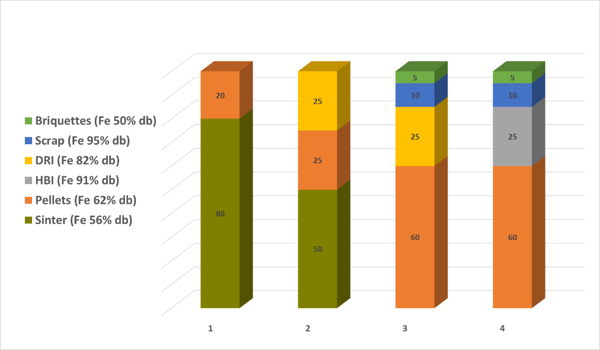

**Fig. 8 –** Burden Compositions with Sinter, Pellets & Metallics

The HBI and DRI compositions are summarized in Table 1 using either DR-grade or BF-grade pellets for their production.

**Tab. 5 –** Pellets, HBI and DRI compositions

The full output of our calculations are summarized in Table 2.

**Tab. 6 –** Results Heat and Mass Balance Calculations

|  |  |  |  |  |  |
| --- | --- | --- | --- | --- | --- |
|  |  | **1** | **2** | **3** | **4** |
| **Sinter / Pellets** | % | 80 / 20 | 50 / 25 | 0 / 60 | 0 / 60 |
| **Metallics** | % | 0 | 25 (DRI) | 40 (DRI) 1) | 40 (HBI) 1) |
| **Gross Coke Rate** | kg/tHM | 313 | 307 | 279 | 230 |
| **Coal Injection Rate** | kg/tHM | 180 | 80 | 60 | 80 |
| **Gas Injection Rate** | kg/tHM | 0 | 0 | 0 | 40 (COG) |
| **Top Gas Temperature** | °C | 109 | 125 | 128 | 130 |
| **RAFT** | °C | 2170 | 2101 | 2125 | 2019 |

Ad1) These metallics also include 10% Scrap and 5% Briquettes

These results indicate that charging of 40% metallics will be feasible within the usual BF process constraints (top gas temperature ≥ 100°C and acceptable RAFT temperature). Charging metallics will, however, reduce the maximum coal injection rate. BF CO2 emissions are summarized in Fig4 and clearly demonstrate the potential of reducing these emissions to less than 1000 kgCO2/tHM when charging pellets & briquettes and metallics instead of sinter. The lowest emissions could be achieved when using HBI made with H2 followed by 80% H2 and 20% NG, however charging DRI made with COG significantly reduce the CO2 emissions making it very attractive for region where natural gas and/or hydrogen are not available

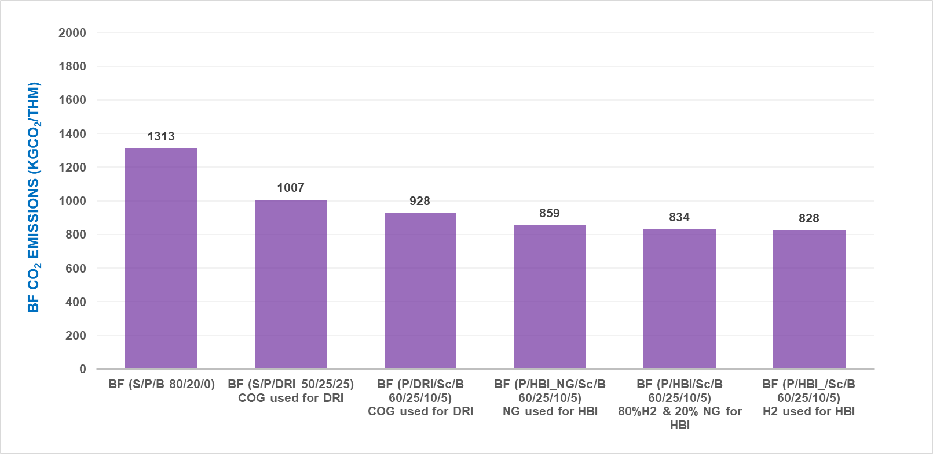

**Fig. 9 –** BF Scope 1 CO2 Emissions

Last but not least, it is commonly understood and agreed that using metallics in the BF allows for higher productivity rates. This could be particularly interesting for steelmaking companies operating several BF’s as higher productivity rates could enable idling one of these without compromising the production capacity.

**Injection of Coke Oven Gas**

Currently, majority of steel producers use coke oven gas to produce electricity within the captive power plant or for various heating purposes within the integrated steel plant. However, this is not the optimal use of coke oven gas from a CO2 emission reduction perspective. Injecting coke oven gas into the blast furnace is an innovative solution with unique characteristics that reduce the CO2 footprint and lower operating costs. The hydrogen-rich coke oven gas, when injected into the blast furnace, reduces the carbon rate and CO2 emissions as carbon (coke or coal) is partially replaced by hydrogen. The injection process not only improves furnace efficiency but also contributes to emission reductions. Implementation is straightforward and can be seamlessly integrated into existing operations, providing an immediate and effective method to meet stringent environmental regulations and sustainability goals.

**Using bio–fuels**

Using bio–fuels in the blast furnace can reduce fossil CO₂ emissions. Bio–fuels, such as bio–coal or charcoal, offer a renewable alternative to partially or fully replace traditional carbon sources like metallurgical coke or pulverized coal. For example, bio–coal is produced from biomass like wood or agricultural residues and has been successfully tried in plants in e.g. Asia. Charcoal, derived from the carbonization of wood, has been employed historically in regions like Brazil due to its availability and cost–effectiveness, with some Blast Furnaces operating on 100% charcoal. When these bio–fuels are integrated effectively into the blast furnace process, they maintain furnace performance while enabling emission cuts. Additionally, the use of bio synthetic natural gas, a renewable natural gas sourced from organic waste, is being explored in some countries. Bio–fuels represent a scalable step toward sustainable steelmaking, providing a viable path for reducing the carbon footprint of one of the most energy–intensive industries.

**HYBRID PLANT CONFIGURATIONS: ARE THERE HIDDEN BENEFITS?**

Our strategy and development program relies on the use of significant amounts of metallics in the blast furnace burden. These metallics will primarily consist of Hot Briquetted Iron (HBI) and/or Direct Reduced Iron (DRI). The availability of scrap may limit its use due to its trace elements, which could complicate the production of high-grade steel in the basic oxygen furnace (BOF). We are also developing technologies to maximize the scrap-to-hot-metal ratio in the BOF charge mix to reduce the demand for BF metal.

We assume that DRI could be produced at the integrated steelmaking site using BF-grade pellets, while HBI would be produced elsewhere using DR-grade pellets. Our experiences with industrial direct reduction plants (DRP) have confirmed the feasibility of producing DRI with BF-grade pellets. The costs of BF-grade pellets and the associated DRI would be lower than those of DR-grade pellets and HBI, but reliably forecasting future pricing premiums of DR-grade pellets isn’t realistic. We also recognize that the relative value-in-use of DRI is less than that of HBI due to DRI's lower iron content, which is considered in the BF heat and mass balance calculations.

Interestingly, the energy requirements for producing DRI and HBI depend on the composition of the reducing and fuel gas. We have assessed the effects of three reducing gas compositions for the DRP with less energy required if more hydrogen is used and/or lower-grade ores are used. This is due to improved gas utilization rates and lower reductant requirements if less iron oxide needs to be reduced.

**Tab. 7** – Energy requirement for DRI

|  |  |  |  |  |  |
| --- | --- | --- | --- | --- | --- |
| **SCENARIO** | | **1** | **2** | **3** | |
| NG | 100% | |  | | 20% |
| H2 |  | |  | | 80% |
| BFG/COG |  | | 100% | |  |
| Energy Required for DRP (Gcal/tHBI, Gcal/tDRI) | 1.6 | | 1.5 | | 1.4 |

The third scenario includes an Electrical Process Gas Heater to reduce CO2 emissions, which would otherwise be generated by using natural gas (NG) or coke oven gas (COG)/blast furnace gas (BFG) for combustion and heating of the process reducing gas. The electrical heater is advantageous in reducing CO2 emissions if the electrical energy source has a lower carbon footprint than the alternative emissions generated by gas combustion. Modularizing the electrical gas heater allows for its staged installation, facilitating a gradual transition toward decarbonized production.

The carbon content in DRI and HBI can be increased by using COG gas in the EnergIron DRP, with the carbon content in DRI pushed to 4%, optimizing melting performance in the BF.

if DRI would be produced at the integrated steelmaking plant which also introduces the option to use COG and BFG for reduction in the DRP. The usage of COG in DRP is already demonstrated at a large steelmaking plant in China. The usage of BFG would need optimization of its integration in the DRP flowsheet.

**COMPARISON OF SCENARIOS**

A comprehensive model has been developed to determine Scope 1 and Scope 2 emissions for a typical integrated steelmaking plant including cokemaking, sintermaking, pelletmaking, BF and DRP ironmaking, BOF steelmaking, casting and also includes electricity, steam, hydrogen & oxygen. Specific CO2 emissions and electricity requirements for different plant areas are summarized in Table 4.

**Tab. 8 –** Specific CO2 Emissions and Electricity Consumption

We have been assuming a constant scrap to hot metal ratio in BOF steelmaking i.e., 900 kgHM/tLS and ~ 147 kgScrap/tLS. With increase in metallics in the BOF mix will further reduce the CO2 emissions.. and also contributes to recycling strategies.

Scope 1 CO2 emissions for our reference case amount to 1983 kgCO2/tCS as illustrated in figure 5. This plant includes BF ironmaking using 80% sinter and 20% pellets in the burden. The electricity balance of our reference plant is negative i.e., this plant exports electricity (made by COG and BFG as BOFG will be used to produce steam). Scope 2 emission are depended on electricity grid carbon intensity therefore be ignored for comparison purpose. Summary of electricity balance for different scenarios is provided in table 5 .

|  |  |  |  |  |  |  |  |
| --- | --- | --- | --- | --- | --- | --- | --- |
|  | Unit | BF  (S/P/B 80/20) | BF (S/P/DRI 50/25/25)  COG used for DRI | BF (P/DRI/Sc/B 60/25/10/5) COG used for DRI | BF (P/HBI_NG/Sc/B 60/25/10/5)  NG used for HBI | BF (P/HBI/Sc/B 60/25/10/5)  80%H2 & 20% NG for HBI | BF (P/HBI_/Sc/B 60/25/10/5)  H2 used for HBI |
| Electricity Balance | kWh/tCS | -124 | 323 | 288 | 65 | 759 | 1233 |

The integrated steelmaking plant Scope 1 CO2 emissions for other scenarios are illustrated in Figure 5. This figure clearly demonstrates advantages of maximizing the metallics ratio in BF burden.

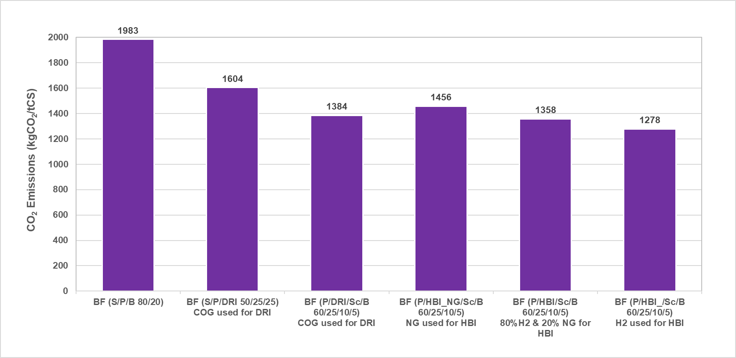

**Fig. 10 –** Crude Steelmaking CO2 Emissions.

**SUMMARY**

Steelmaking decarbonization requirements are challenging our industry and necessitate a shift towards DRI and EAF processes as well as changes to current BF-BOF steelmaking practices. Existing and modern BF’s and BOF’s will be retained at large capacity during the next decades, especially given their capability to produce high-grade steel using low-grade ores.

ENERGIRON DR technology is the most efficient method for reducing CO2 emissions in the steelmaking sector, thanks to its inherent qualities. It not only meets the most stringent global environmental standards but also facilitates the reuse of effluents & emissions as valuable resources. In essence, ENERGIRON DRI technology stands as a testament to the convergence of innovation and sustainability, its unparalleled flexibility in accommodating diverse pellet qualities and feedstock gases, coupled with its steadfast commitment to producing high-quality DRI, Embodies the spirit of progress driving the modern steelmaking landscape. As the industry continues to evolve, ENERGIRON stands at the forefront, reshaping the contours of steel production for generations to come.

Danieli is committed to assisting its clients by offering sustainable, customized solutions for CO2 emission reduction, covering everything from initial feasibility studies to the implementation of turnkey projects. Tailored solutions are crafted based on ENERGIRON plants, which can operate independently or be integrated seamlessly with electric minimills or blast furnaces. These solutions are designed to optimize OPEX while maintaining high steel quality, within sustainable capital investment strategy.

Effective changes to BF ironmaking include the usage of pellets & briquettes and metallics i.e., scrap, HBI and/or DRI. The usage of pellets & briquettes and metallics could be deployed at large scale in coming years present an immediate solution to reduce carbon footprint significantly.

BF-grade pellets can also be used for the production of DRI at integrated steelmaking plants using their plant gases i.e., COG & BFG, which is highly beneficial in terms of both DRI production efficiency and allocation of the Coke Oven Gas and Blast Furnace Gas.

The highest level of steelmaking decarbonization is achieved by shifting capacity towards DRI and EAF processes.

Reducing BF–BOF crude steelmaking CO2 emissions from ~ 2.0 tCO2/tCS to less than 1.2 tCO2/tCS requires BF ironmaking CO2 emissions to be reduced to less than 1000 kgCO2/tHM. We have presented a realistic scenario based on using pellets, briquettes and metallics in the burden. These practices are all proven and the emission reduction can be effected on the short term, allowing for an actual acceleration of steel industry decarbonization towards 2030.

Further to these, the application of bio-fuels could further reduce the CO2 emissions and reduce the dependence on fossil fuels.

A hybrid scenario with DRP-BF-BOF steelmaking is a sustainable and represents an attractive configuration for many existing BF-BOF steelmaking companies to counter potential CO2 emissions costs coming years.

**REFERENCES**

1. Lapasin M, Pauluzzi D, Mahmoud M. Blast furnace transition towards DRP, CO2 reduction and Hydrogen usage in ENERGIRON® plants. 9th European Coke and Ironmaking Conference. 2024 October 16–18; Bardolino, Italy.
2. Van Laar R, Verma D, De Weerdt J, Sultan H, Lapasin M, Pauluzzi D. Blast Furnace Ironmaking Decarbonization using Pellets and Metallics. Millennium Steel 2025.